|  |  |
| --- | --- |
| **E. LAMB AND SON**  ***Est. 1944***  ***Spares / Appliances***  ***Solid Fuels Bottled Gas***  **Tel: 01946 830353** | **Lynda Elliot**  **Hairdresser**  **C:\Users\Barbara Lamb\AppData\Local\Microsoft\Windows\Temporary Internet Files\Content.IE5\06JCVCET\MC900324786[2].wmf**  **Tel: 01946 830504**  **Mobile: 07798 648233** |
| **YEOWART, GILL AND RUDD**  **Chapel of Rest, Low Monkwray**  **Prop: John, David & Margaret Yeowart**  The Family funeral service  People committed to a dignified service at the lowest cost  GOLDEN CHARTER  Pre-paid Funeral Plan  Details available on request  **Tel: 01946 693819/692939**  **(24 hours)**  **Beware of recommendations that could be costly!!** | **TOM EDGAR**  **Funeral Services**  Caxton House, Brow Top  Workington  Private Chapel of Rest  Tel: 01900 603388  Residence: 41 Stainburn Road  Fax: 01900 606625  **24 HOUR SERVICE** |



**Church of the Holy Spirit**

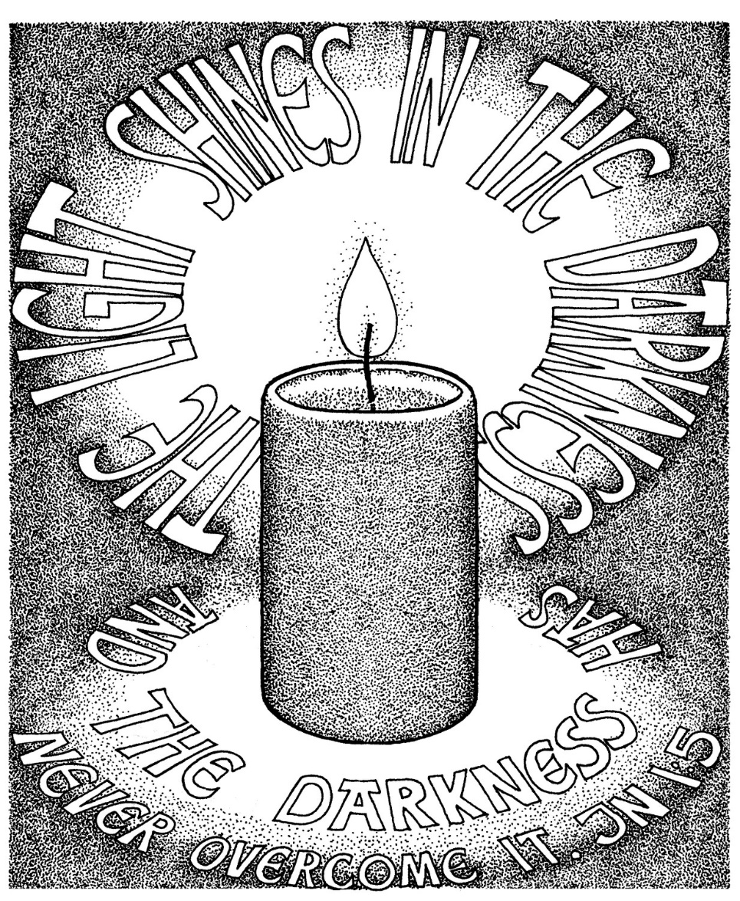

**Parish Magazine**

**What’s on in the village?**

**All of the following activities take place in the Community Centre. For further details please telephone 01946 834297**

**Baby & Toddler Group:** Every Wednesday (Term Time) 10am

**Lunch Club:** 2nd Friday of the month at 12 noon

**Family and Local History:** Every third Tuesday from 7 - 9 pm

**Art Class**: Most Tuesdays from 6.15 – 8.15 pm

**Craft Club**: Every Tuesday from 1 - 3 pm

**Evergreens**: Thursdays from 1 – 3 pm

**Reading Group:** Every second Monday from 2 pm (in the Library)

**Knit and Knatter:** Every Friday from 1 -3 pm

**“Old Folks” Bingo**: Every Monday at 8 pm

**Fit 4 Life**: Every Tuesday from 11 – 12.15 am

**Parish Council** meets every second Monday at 7 pm in the Club for Young People

**Mothers Union**: every first Wednesday in the month at 7 pm in the Community Centre

**Distington Club for Young People**: if you require further information please contact Christine on 832882

-o-o-o-o-o-o-o-o-o-o-o-o-o-o-o-o-o-o-o-o-o-o-o-o-o-o-o-o-o-o-o-

**THANK YOU**

A very big thank you to all those who contributed from Distington and from Harrington, towards the Shoe Box Appeal. We have sent 10 boxes which were packed to capacity with a wide range of goodies.

Barbara Lamb

|  |  |
| --- | --- |
|  | **John Sandelands and Son**  Joiners and Funeral Directors  Private Chapel of Rest  Hay Lodge  56a Main Road  Seaton  Workington CA14 1HU  Tel: 01900 602753 |

**Wall & Tree Cockermouth**

* **Hedge & Tree maintenance & removals**
* **Grass Cutting, garden tidying & clearances**
* **Small landscaping projects**
* **Fence installation, painting & repair**
* **Firewood & chainsaw work**
* **General garden D.I.Y.**

**We can work within your budget**

**Contact Dale for a no obligation quotation**

**Tel. 01900 828946 mob 07907 225 316**

**E-mail moose.moore@live.co.uk**

**THE CHURCH OF THE HOLY SPIRIT, DISTINGTON**

**Rector: Revd. Julia Powley, The Rectory, Rectory Close, Harrington, Workington, CA14 5PN Tel: 01946 830215**

**Churchwardens Marlene Pettit**

**Lay Chair Doreen Belford**

**Secretary Barbara Lamb**

**Treasurer Doreen Belford**

**Electoral Roll**

**Officer Barbara Lamb**

**PCC Members as above plus**

**Helen Finn, Julia Hoggarth, Nicola Stephenson, Pat Nelson, Rhoda Robinson & Rosalind Brough**

**Sides Persons Myra Allen, Ann Blakemore, Joan, Milligan, Rosalind Brough, Sandra Parry, Brenda Bailey & Pat Nelson**

|  |  |  |
| --- | --- | --- |
| **For any information needed about Baptisms, Weddings or Funerals please contact**  **Revd. Julia Powley Tel: 01946 830215** | | |
| **Triple TTT Ltd**  **The Old Job Specialists doing the Jobs you hate**  ***Window cleaning – power spraying***  ***Guttering – painting – brick laying***  **Van Hire with Driver, fully insured – mini removals**  ***Grasscutting – tree pruning – hedge cutting***  ***Commercial and household cleaning***  **COMPETITIVE QUOTES**  **01900 810008**  **07934 770328** | **Advertise Here?**  **Find out more about our great yearly rates**  **for more information, contact**  **Barbara Lamb**  **07425 792 995** |
| **Brockbank Curwen Cain and Hall**  Solicitors and Notaries  44 Duke Street  Whitehaven CA28 7NR  Tel: 01946 692195  Also at Cockermouth, Maryport, Workington and Keswick   * **Home Information Packs** * **Residential and Commercial Conveyancing** * **Wills and Probate** * **Court of Protection** * **Personal Injury** * **Matrimonial** * **Crime** * **Employment**   www.brockbanks.co.uk | **DISTINGTON**  **COMMUNITY CENTRE**  **The Centre runs training events and other community activities including public meetings. The Mabel Knowles room is a committee room available for small meetings – capacity 25. The Main hall is available for events, activities, and private parties etc. – capacity 100.**  **Full kitchen available**  **For further details**  **tel: 01946 834297** |

**Flowers**

Do you have loved ones who you like to remember with flowers?

Did you know you can display flowers in memory of your loved ones in church?

These can be displayed on the altar or throughout the church.

**For more information please speak to**

**Nicola Stephenson on 07933551524.**

**Church Memorial Book**

If anyone would like to have their loved one’s details added to our memorial book in Church, please speak with Julia Powley.

There will be a small charge of £5 per name

Dear everyone,

I think I have found my favourite Christmas advert for this year. Actually, it was a 2017advert. It’s the story of a lonely man who finds a dog living rough. He takes the dog home, cleans him up and gains his trust. They become great friends. Then one day, while out for a walk with the dog, the man sees a poster, with a picture of the dog, Chobo, and the telephone number of the family who had lost him. He agonises, but then phones the family and gives them the dog back. Back home, one of that family notice the collar which the man has put on the dog, with a little angel pendant. The family go back for the man and bring him to their home for Christmas. So, they share the dog, and become friends. The final strapline was “From unexpected friendships to lasting relationships.”

That picture of sharing, of not needing to exclude others, of not needing to keep everything for ourselves, has to be central to any real celebration of Christmas. It tells us so much about the heart of God and his love for us. He did not need to bother. He did not need to come down and live in the mess of this world. He could have kept Heaven for himself. But instead, in his amazing generosity, he gave us everything by giving us himself, born as a baby, living under enemy occupation, dying and rising again for us and offering share Heaven with us. Sheer generosity. Sheer unbounded and unconditional love. That is what Christmas is about.

How will we mark this Christmas? I pray that, as we revel in his generosity, we may extend that to those on the edges, those who need to share what we have and with whom we need to share our God. Our society is starved of generosity as we are told to go for whatever we want, whatever it costs other people or the planet. Christmas turns that upside down.

I wish you a happy, love-filled and laughter-filled Christmas, and a New Year where we all know the peace of Christ, whatever is going on in the world.

With love,

Julia

The Church of the Holy Spirit warmly invites you to our…..

**Baby and Toddler Group**

Distington Community Centre

Every Wednesday in school term time

10am start

Babies and toddlers with their parents/carers are welcome

£1 per family

For more information please contact Julia Hoggarth on 07747581390

**Last Toddler before Christmas is**

**19th December 2018**

**Lunch Club**

Monthly on the 2nd Friday 12noon - 2pm

Next two are;

**14th December 2018**

**11th January 2019**

Distington Community Centre

Beautiful food served at fantastic prices

One, two or three courses with tea & coffee

**Your Church Needs You!**

* To go on the rota to read a lesson
* To go on the list to lead prayers
* To go on the cleaning rota
* To go the rota to print the magazine
* To be a sidesperson
* To be a member of the PCC

If you can help, please speak with

Julia Powley

**From the Parish Registers**

**Funerals**

May they Rest in Peace

**Elsie Christopherson**

Age 78 years

Died 1st October 2018

Funeral 12th October 2018

**Baptisms**

We welcome by Baptism into the Lords Family

**William Downey**

Born 8th February 2018

Baptised 21st October 2018

**CHURCH CLEANING ROTA**

**DECEMBER 2018**

2nd Lynda & Ann,

9th Sandra & Trudy,

16th Katherine & Carl,

23rd Julia & Helen,

30th Lynda & Ann

**JANUARY 2019**

6th Sandra & Trudy,

13th Katherine & Carl,

20th Julia & Helen,

27th Lynda & Ann

February 3rd Sandra & Trudy

If you are unable to make the week you are due to clean, please let Sandra know on 01946 830046.

**Website**

We have a new website for the United Benefice which covers the activities of both St Mary’s Harrington and The Holy Spirit Distington. The website is still in development, so we are looking for comments and ideas to include. Have a look and tell either James Mossop or Andrew Callaway (me!) what you think. The web address is [www.stmarys-harrington-and-holyspirit-distington.co](http://www.stmarys-harrington-and-holyspirit-distington.co) If you want to email your thoughts my email address is [a.callaway@talktalk.net](mailto:a.callaway@talktalk.net)

Thanks Andrew

**Daily Coffee and Chat**

Read the Papers or Listen to the Radio

Distington Methodist Chapel

Daily from 10am – 12noon

All Welcome

**Future Dates for your Diary!**

**Distington School Carol Service**

20th December 2018 2pm in Church

**Christmas Carol Service**

23rd December 2018 4pm in Church

**Crib Service**

24th December 2018 5.30pm in Church

**Midnight Mass**

24th December 2018 11.30pm in Church

**Christingle Service**

**11th December 2018 – 6pm**

During the days before, the children at school will have made Christingles.

Everyone is invited to come and celebrate our annual Christingle Service that evening at 6pm in church, when the Christingles will be lit. This is for everyone in the community and it would be great to see as many people as possible there.

Remember your loved ones with a special message on a tag which will be displayed on our Church Christmas Tree.

Tags are available for £5 each

Speak to Pat Nelson, Julia Powley, Nicola Stephenson or they are available in Church

**FoodShare Food Heroes!**

Some of our residents have been working with Distington Big Local, Citizens Advice Bureau and Credit Union since July, helping to deliver our newest project, The FareShare Scheme, delivering fresh food to local residents each week.

The scheme was originally set up as a pilot project in Distington and has grown each week, with new residents joining.

We are very proud of what this has provided in our village, ensuring that food is available weekly for people who are struggling.

FareShare takes place from Distington Library

each Tuesday 2pm-3pm

**Church of the Holy Spirit**



[This Photo](https://www.flickr.com/photos/birdies100/69716360/) by Unknown Author is licensed under [CC BY-SA](https://creativecommons.org/licenses/by-sa/2.0/)

**CHRISTMAS FAIR**

**Sunday 2nd December**

**12 noon start**

**DISTINGTON COMMUNITY CENTRE**

**Tombola Raffle Cake stall**

**Craft stall**

**Turkey rolls *** Tea *** Coffee**

**EVERYONE WELCOME**

|  |  |
| --- | --- |
| **DECEMBER** | |
| **Date** | **Event** |
| Sun 02/12/2018 | 9.15 - Family Worship 12 noon - Christmas Fair in Community Centre 7pm - Study Group in Harrington Rectory |
| Mon 03/12/2018 | 7pm - Solway Deanery Mothers Union Advent Carol Service in St Marys Harrington |
| Wed 05/12/2018 | 9.30am - Holy Communion 10am - Toddler Group in Community Centre |
| Sun 09/12/2018 | 9.15am - Holy Communion 11.30ish - Christmas Fair at St Marys Harrington 4pm - Distington Village Tree Lights Switch on |
| Tue 11/12/2018 | 6pm - Village & School Christingle Service |
| Wed 12/12/2018 | 9.30am - Holy Communion 10am - Toddler Group in Community Centre |
| Sun 16/12/2018 | 9.15am - Holy Communion |
| Wed 19/12/2018 | 9.30am - Holy Communion 10am - Final Toddler Group in Community Centre before Christmas |
| Thu 20/12/2018 | 2pm - School Carol Service in Church |
| Sun 23/12/2018 | NO MORNING SERVICE 4pm - Carols by Candlelight |
| Mon 24/12/2018 | 5.30pm - Crib Service 11.30pm - Midnight Eucharist |
| Wed 26/12/2018 | NO SERVICE IN CHURCH |
| Sun 30/12/2018 | 9.15am - Holy Communion |

|  |  |
| --- | --- |
| **JANUARY** | |
| **Date** | **Event** |
| Wed 02/01/2019 | 9.30am - Holy Communion |
| Sun 06/01/2019 | 9.15am - Holy Communion |
| Wed 09/01/2019 | 9.30am - Holy Communion 10am - Toddler Group in Community Centre |
| Sun 13/01/2019 | 9.15am - Holy Communion 7pm - Study Group Harrington Rectory |
| Wed 16/01/2019 | 9.30am - Holy Communion 10am - Toddler Group in Community Centre 7.30pm - PCC Meeting |
| Fri 18/01/2019 | 7pm - Film Club at Harrington |
| Sat 19/01/2019 | 4pm - Messy Mary's at Harrington |
| Sun 20/01/2019 | 3pm - Church in the Afternoon |
| Wed 23/01/2019 | 9.30am - Holy Communion 10am - Toddler Group in Community Centre |
| Sat 26/01/2019 | Prayer Ministry Training in St Mary's Hall. Speak with Julia if you are interested. |
| Sun 27/01/2019 | 9.15am - Holy Communion 7pm - Study Group Harrington Rectory |
| Wed 30/01/2019 | 9.30am - Holy Communion 10am - Toddler Group in Community Centre |

**Confirmation**

On June 2nd at 3pm, our new bishop, Emma Ineson, will be coming to join us for our confirmation service. Confirmation is an opportunity to make public statements of faith and is open to anyone aged from year 6 to over 100. If you fit into that age bracket and would like to think about getting confirmed, please have a word with Julia. We will be starting to have confirmation preparation sometime in the New Year.

**100 Club Winners**

September – No 42 – Barbara Bell

October – No 1 – Doreen Belford

November – No 21 – Stephen Daniel

December – No 23 – Julia Hoggarth

January – No 6 – Ray Bailey

**How to survive Christmas**

* *Remember the reason for the season.* It’s Jesus’ birthday, not yours!
* *Plan ahead.* How much can you realistically afford? Don’t just head for the shops with your credit card.
* *Don’t do the last-minute buying frenzy.* Shop early, when you can think clearly.
* *Christmas is an expensive time of year for everyone.*  With some close friends and adults in the family you may be able to make a ‘no presents’ pact.
* *Try shopping with cash only* – that way you can’t spend more than your budget.
* *Don’t let children* *talk you into* *buying expensive items* you can’t afford.
* *Don’t go overdrawn* without telling your bank in advance. The penalties are high!
* *Don’t go mad in the January sales,* and avoid the temptation of the numerous ‘buy now pay later’ offers.
* *Help other people whenever you can.* After all, it is the season of goodwill!
* *Be tolerant of visiting relatives.* They want to enjoy Christmas as much as you do, honestly. They don’t mean to be quite *that*
* *Be grateful for your presents.* Even when they are hideous. Somebody, somewhere, will like them in the New Year.
* *Forget all of your worries for one day of the year.* Whatever they are, just relax and enjoy celebrating the birth of Christ!
* *Finally, if you do run into debt problems,* don’t ignore them. Get advice as early as possible. Contact Christians Against Poverty or your nearest Citizens Advice Bureau for free, confidential, independent advice.

|  |  |  |  |  |
| --- | --- | --- | --- | --- |
|  | **READINGS** | **READER** | **SIDESPERSON** | **FLOWERS** |
| **2nd December** | **1 Thessalonians 3 vs 9 - 13 Luke 21 vs 25 - 36** | **Childrens Church** | **Brenda Bailey Joan Armstrong** | **Nicola Stephenson** |
|
| **9th December** | **Malachi 3 vs 1 - 14 Luke 3 vs 1 - 6** | **Ray Bailey Rector** | **Rosalind Brough Pat Nelson** | **Nicola Stephenson** |
|
| **16th December** | **Philippians 4 vs 4 - 7 Luke 3 vs 7- 18** | **Sandra Rector** | **Rosalind Brough Pat Nelson** | **Parishioners** |
|
| **23rd December** |  | **Various** | **Barbara Lamb Brenda Bailey** | **Parishioners** |
|
| **24th December** | **Isaiah 9 vs 2 - 7 Luke 2 vs 1 - 20** | **Barbara Lamb Rector** | **Barbara Lamb Brenda Bailey** | **Parishioners** |
|
| **25th December** | **Isaiah 52 vs 7 - 10 John 1 vs 1 - 14** | **Doreen Belford Rector** | **Barbara Lamb Brenda Bailey** | **Parishioners** |
|
| **30th December** | **Colossians 3 vs 12 - 17 Luke 2 vs 41 - 52** | **Sandra Rector** | **Sandra Parry Ann Blakemore** | **Parishioners** |
|

|  |  |  |  |  |
| --- | --- | --- | --- | --- |
|  | **READINGS** | **READER** | **SIDESPERSON** | **FLOWERS** |
| **6th January** | **Isaiah 60 vs 1 - 6 Matthew 2 vs 1 - 12** | **Childrens Church** | **Sandra Parry Ann Blakemore** | **Mrs Kirkbride** |
|
| **13th January** | **Isaiah 43 vs 1 - 7 Luke 3 vs 15 - 17 and 21 - 22** | **Ray Bailey Rector** | **Rosalind Brough Pat Nelson** | **Marlene Pettit** |
|
| **20th January** | **1 Corinthians 12 vs 1 - 11 John 2 vs 1 - 11** | **Doreen Belford Rector** | **Rosalind Brough Pat Nelson** | **Barbara Lamb** |
|
| **27th January** | **1 Corinthians 12 vs 12 - 31a**  **Luke 4 vs 14 - 21** | **Sandra Parry Rector** | **Barbara Lamb Brenda Bailey** | **Barbara Lamb** |
|

Loving, generous Father,

This Christmas, please help us to keep you at the centre of our preparations and celebrations. May our thankfulness for the gift of your precious son, Jesus, motivate all that we think and say and do. May the joy of His coming shine from us and attract those who don’t know what Christmas really means, so that they want to find out!  
In Jesus’ name and for His glory,  
Amen.

