|  |  |
| --- | --- |
| **E. LAMB AND SON**  ***Est. 1944***  ***Spares / Appliances***  ***Solid Fuels Bottled Gas***  **Tel: 01946 830353** | **Lynda Elliot**  **Hairdresser**  **C:\Users\Barbara Lamb\AppData\Local\Microsoft\Windows\Temporary Internet Files\Content.IE5\06JCVCET\MC900324786[2].wmf**  **Tel: 01946 830504**  **Mobile: 07798 648233** |
| **YEOWART, GILL AND RUDD**  **Chapel of Rest, Low Monkwray**  **Prop: John, David & Margaret Yeowart**  The Family funeral service  People committed to a dignified service at the lowest cost  GOLDEN CHARTER  Pre-paid Funeral Plan  Details available on request  **Tel: 01946 693819/692939**  **(24 hours)**  **Beware of recommendations that could be costly!!** | **TOM EDGAR**  **Funeral Services**  Caxton House, 13 Brow Top  Workington, CA14 2DP  Private Chapels of Rest  Tel: 01900 603388  Email: tom.edgar1@btconnect.com  **24 HOUR SERVICE** |



**Church of the Holy Spirit**



**Parish Magazine**

**What’s on in the village?**

**All of the following activities take place in the Community Centre. For further details please telephone 01946 834297**

**Baby & Toddler Group:** Every Wednesday (Term Time) 10am

**Lunch Club:** 2nd Friday of the month at 12 noon

**Family and Local History:** Every third Tuesday from 7 - 9 pm

**Art Class**: Most Tuesdays from 6.15 – 8.15 pm

**Craft Club**: Every Tuesday from 1 - 3 pm

**Evergreens**: Thursdays from 1 – 3 pm

**Reading Group:** Every second Monday from 2 pm (in the Library)

**Knit and Knatter:** Every Friday from 1 -3 pm

**“Old Folks” Bingo**: Every Monday at 8 pm

**Fit 4 Life**: Every Tuesday from 11 – 12.15 am

**Parish Council** meets every second Monday at 7 pm in the Club for Young People

**Mothers Union**: every first Wednesday in the month at 7 pm in the Community Centre

**Distington Club for Young People**: if you require further information please contact Christine on 832882

-o-o-o-o-o-o-o-o-o-o-o-o-o-o-o-o-o-o-o-o-o-o-o-o-o-o-o-o-o-o-o-

|  |  |
| --- | --- |
|  | **John Sandelands Funeral Directors Ltd**  **Tel: 01900 602753**  **Rest Chapels at;**  Main Road, Seaton  South William St, Workington  Bridge Street, Cockermouth |

**Wall & Tree Cockermouth**

* **Hedge & Tree maintenance & removals**
* **Grass Cutting, garden tidying & clearances**
* **Small landscaping projects**
* **Fence installation, painting & repair**
* **Firewood & chainsaw work**
* **General garden D.I.Y.**

**We can work within your budget**

**Contact Dale for a no obligation quotation**

**Tel. 01900 828946 mob 07907 225 316**

**E-mail moose.moore@live.co.uk**

**THE CHURCH OF THE HOLY SPIRIT, DISTINGTON**

**Rector: Revd. Julia Powley, The Rectory, Rectory Close, Harrington, Workington, CA14 5PN Tel: 01946 830215**

**Churchwardens Marlene Pettit**

**Lay Chair Doreen Belford**

**Secretary Barbara Lamb**

**Treasurer Doreen Belford**

**Electoral Roll**

**Officer Barbara Lamb**

**PCC Members as above plus**

**Helen Finn, Julia Hoggarth, Nicola Stephenson, Pat Nelson, Rhoda Robinson, Ray Bailey & Rosalind Brough**

**Sides Persons Myra Allen, Ann Blakemore, Joan, Milligan, Rosalind Brough, Sandra Parry, Brenda Bailey & Pat Nelson**

|  |  |  |
| --- | --- | --- |
| **For any information needed about Baptisms, Weddings or Funerals please contact**  **Revd. Julia Powley Tel: 01946 830215** | | |
| **Triple TTT Ltd**  **The Old Job Specialists doing the Jobs you hate**  ***Window cleaning – power spraying***  ***Guttering – painting – brick laying***  **Van Hire with Driver, fully insured – mini removals**  ***Grasscutting – tree pruning – hedge cutting***  ***Commercial and household cleaning***  **COMPETITIVE QUOTES**  **01900 810008**  **07934 770328** | **Advertise Here?**  **Find out more about our great yearly rates**  **for more information, contact**  **Barbara Lamb**  **07425 792 995** |
| **Brockbank Curwen Cain and Hall**  Solicitors and Notaries  44 Duke Street  Whitehaven CA28 7NR  Tel: 01946 692195  Also at Cockermouth, Maryport, Workington and Keswick   * **Home Information Packs** * **Residential and Commercial Conveyancing** * **Wills and Probate** * **Court of Protection** * **Personal Injury** * **Matrimonial** * **Crime** * **Employment**   www.brockbanks.co.uk | **DISTINGTON**  **COMMUNITY CENTRE**  **The Centre runs training events and other community activities including public meetings. The Mabel Knowles room is a committee room available for small meetings – capacity 25. The Main hall is available for events, activities, and private parties etc. – capacity 100.**  **Full kitchen available**  **For further details**  **tel: 01946 834297** |

**Flowers**

Do you have loved ones who you like to remember with flowers?

Did you know you can display flowers in memory of your loved ones in church?

These can be displayed on the altar or throughout the church.

**For more information please speak to**

**Nicola Stephenson on 07933551524.**

**Church Memorial Book**

If anyone would like to have their loved one’s details added to our memorial book in Church, please speak with Julia Powley.

There will be a small charge of £5 per name

Dear friends,

I am writing this on a beautiful morning at Rydal Hall. There has been some snow over night but not too much, and the sun is shining, not a breath of wind blowing. Just perfect. As I walked along the path, enjoying the peace, the quiet was interrupted by a long line of sheep, shouting at the top of their voices, some at full gallop across a field and some walking more slowly. The excitement was caused by their shepherd, at the other side of the field, offering them food.

What struck me was how the sheep at the back of the line even heard the shepherd. But, of course, they did not need to hear him for themselves as they set off on their journey. All they had to do was follow the sheep in front of them. But at some stage, they would need to decide for themselves whether they trusted that man with the food, whether they dared to try it for themselves. On a snowy day, no doubt the decision would be easier than if it was the middle of summer.

It is a good picture of the Christian life. Jesus offers us food, whatever is going on in our lives. At first, we don’t know whether to trust him, even whether he exists. But we know people who do trust him and who know him. And so, at first, all we need to do is follow, see what they receive. But at some stage we need to decide for ourselves whether we want to eat.

I wonder where we are on the journey across a snowy field. Are we galloping towards a loving and gracious Lord who longs to provide for our needs? Perhaps we were galloping but right now we have slowed down, maybe not so sure as we used to be, perhaps because of what has happened on the journey so far. Perhaps we are just not sure of him, but we know people who are.

Wherever we are on that journey, I pray that none of us will miss out on what we are offered, especially in these uncertain and challenging times. If you are looking to move forward on the journey, I would love to have the conversation with you.

With love,

Julia

The Church of the Holy Spirit warmly invites you to our…..

**Baby and Toddler Group**

Distington Community Centre

Every Wednesday in school term time

10am start

Babies and toddlers with their parents/carers are welcome

£1 per family

For more information please contact Julia Hoggarth on 07747581390

**No Toddlers on 20th February 2019**

**Lunch Club**

Monthly on the 2nd Friday 12noon - 2pm

Next one is;

**8th February 2019**

Distington Community Centre

Beautiful food served at fantastic prices

One, two or three courses with tea & coffee

**Your Church Needs You!**

* To go on the rota to read a lesson
* To go on the list to lead prayers
* To go on the cleaning rota
* To go the rota to print the magazine
* To be a sidesperson
* To be a member of the PCC

If you can help, please speak with

Julia Powley

**From the Parish Registers**

**Funerals**

May they Rest in Peace

**Margaret Milligan**

Age 73 years

Died 23rd October 2018

Funeral 5th November 2018

**Sharon Weaver**

Age 48 years

Died 29th November 2018

Funeral 11th December 2018

**Baptisms**

We welcome by Baptism into the Lords Family

**Ted Sutton**

Born 18th January 2018

Baptised 4th November 2018

**CHURCH CLEANING ROTA**

**FEBRUARY 2019**

3rd Sandra & Trudy

10th Katherine & Carl,

17th Julia & Helen,

24th Lynda & Ann

March 3rd Sandra & Trudy

If you are unable to make the week you are due to clean, please let Sandra know on 01946 830046.

**Website**

We have a new website for the United Benefice which covers the activities of both St Mary’s Harrington and The Holy Spirit Distington. The website is still in development, so we are looking for comments and ideas to include. Have a look and tell either James Mossop or Andrew Callaway (me!) what you think. The web address is [www.stmarys-harrington-and-holyspirit-distington.co](http://www.stmarys-harrington-and-holyspirit-distington.co) If you want to email your thoughts my email address is [a.callaway@talktalk.net](mailto:a.callaway@talktalk.net)

Thanks Andrew

**Daily Coffee and Chat**

Read the Papers or Listen to the Radio

Distington Methodist Chapel

Daily from 10am – 12noon

All Welcome

**Confirmation**

On June 2nd, 2019 at 3pm, our new bishop, Emma Ineson, will be coming to join us for our confirmation service. Confirmation is an opportunity to make public statements of faith and is open to anyone aged from year 6 to over 100. If you fit into that age bracket and would like to think about getting confirmed, please have a word with Julia. We will be starting to have confirmation preparation sometime in the New Year.

**100 Club Winners**

February – No 22 – Christine Hewitt

|  |  |  |  |  |
| --- | --- | --- | --- | --- |
|  | **READINGS** | **READER** | **SIDESPERSON** | **FLOWERS** |
| **3rd February** | **Malachi 3 vs 1 - 5 Luke 2 vs 22 - 40** | **Childrens Church** | **Barbara Lamb Brenda Bailey** | **Barbara Lamb** |
|
| **10th February** | **Isaiah 6 vs 1 - 8 Luke 5 vs 1 - 11** | **Ray Bailey Rector** | **Sandra Parry Ann Blakemore** | **Doreen Belford** |
|
| **17th February** | **Jeremiah 17 vs 5 - 10 Luke 6 vs 17 - 26** | **Doreen Belford Rector** | **Sandra Parry Ann Blakemore** | **Doreen Belford** |
|
| **24th February** | **Revelation 4 Luke 8 vs 22 - 25** | **Sandra Parry Rector** | **Rosalind Brough Pat Nelson** | **Julia Hoggarth** |
|

**Prayer for revelation**

Heavenly Father,

Thank You for loving us.

Thank You for sending Jesus and for the work of Your Holy Spirit in opening people’s eyes to recognise Him.

Please open our eyes and hearts afresh to Him.

Help us to truly trust Him and to be aware of the price He paid so that we can know Your peace and live with You forever.



**Nigerian Christians under relentless attack**

Gyang, a 27-year old Nigerian Christian is a student at the Department of Civil Engineering at the University of Jos.  A few weeks ago Gyang saw a post on Facebook about how his village had come under attack from Fulani militants. Almost immediately he called home to speak to his father, the Rev Adamu Gyang, but his father’s phone was switched off.

Sensing something was wrong, he called his mother, but her phone was switched off too.  A few minutes later he called a friend who told him that both his parents, his three younger siblings and his grandmother were dead.  They were among many villagers who had been killed in the village when the militants arrived one evening.

During that dreadful night the Fulani burned 95 homes. Most of the village’s crops that were almost ready to harvest were also destroyed. Now Gyang is the only surviving member of his family of seven.

Unfortunately, this situation is all too common in parts of Nigeria, where the persecution and killing of Christians is on the increase. But it is not just in Nigeria.  In Eritrea, Pakistan, Somalia, Kenya, Egypt and India Christians are also being murdered for their faith. Often, those who are left behind find it hard to keep going.

If you want to help the survivors of these attacks, who desperately need food, shelter, medicines and spiritual encouragement, go to <https://cafdonate.cafonline.org>

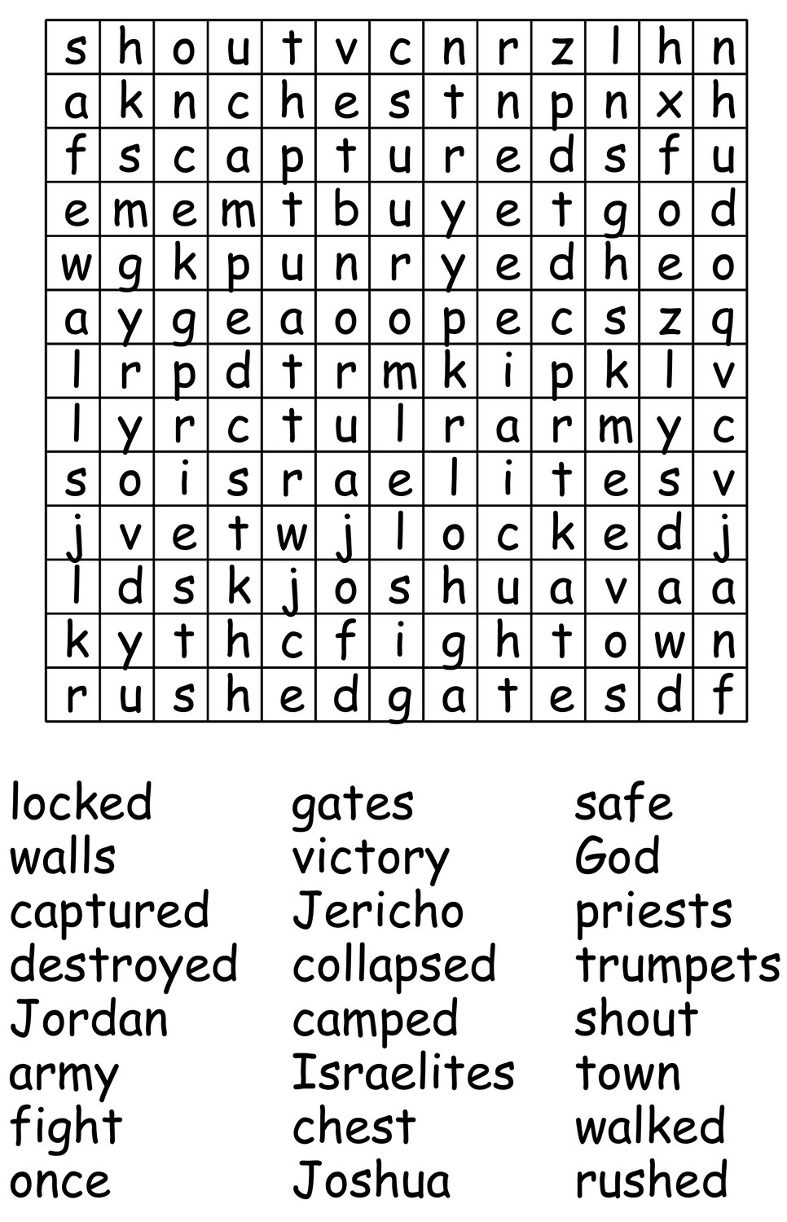

|  |  |
| --- | --- |
| **FEBRUARY** | |
| **Date** | **Event** |
| Sun 03/02/2019 | 9.15am - Family Communion |
| Wed 06/02/2019 | 9.30am - Holy Communion 10am - Toddler Group in Community Centre |
| Sun 10/02/2019 | 9.15am - Holy Communion |
| Wed 13/02/2019 | 9.30am - Holy Communion 10am - Toddler Group in Community Centre |
| Sat 16/02/2019 | 4pm - Messy Marys at Harrington Church Hall |
| Sun 17/02/2019 | 3pm - Church in the Afternoon |
| Wed 20/02/2019 | 9.30am - Holy Communion No Toddler Group in Community Centre |
| Fri 22/02/2019 | 7pm - Film Club |
| Sun 24/02/2019 | 9.15am - Holy Communion |
| Wed 27/02/2019 | 9.30am - Holy Communion 10am - Toddler Group in Community Centre |

**A polite notice to everyone who has laid Christmas Wreaths on loved one’s graves in the churchyard. Please can all wreaths be removed by the end of February 2019 to allow the first grass cut of the new year to take please.**



**Distington Surgery**

**Online Services**

Did you know you can book appointments and order medication online? Please just ask at reception and this can be arranged instantly.

GP and Nurse appointments are now available in your area during the evenings and at the weekend.

To book an appointment contact the surgery on 01946 830 207

To allow essential staff training to take place please note that the surgery (including the dispensary) will be closed from 13:00pm on the dates listed below and will re-open at 8:00am the following morning (for the surgery) and 09:00am (for the dispensary.

Wednesday 13th February 2019

Thursday 14th March 2019

When our GP Practice is closed, patients should call the NHS 11 service by dialling 111

People with communication difficulties or impaired hearing are able to use the NHS 111 service via a textphone by calling 18001 111. Calls are connected to the TextDirect system and the textphone will display messages to let the user what is happening.