|  |  |
| --- | --- |
| **E. LAMB AND SON**  ***Est. 1944***  ***Spares / Appliances***  ***Solid Fuels Bottled Gas***  **Tel: 01946 830353** | **Lynda Elliot**  **Hairdresser**  **C:\Users\Barbara Lamb\AppData\Local\Microsoft\Windows\Temporary Internet Files\Content.IE5\06JCVCET\MC900324786[2].wmf**  **Tel: 01946 830504**  **Mobile: 07798 648233** |
| **YEOWART, GILL AND RUDD**  **Chapel of Rest, Low Monkwray**  **Prop: John, David & Margaret Yeowart**  The Family funeral service  People committed to a dignified service at the lowest cost  GOLDEN CHARTER  Pre-paid Funeral Plan  Details available on request  **Tel: 01946 693819/692939**  **(24 hours)**  **Beware of recommendations that could be costly!!** | **TOM EDGAR**  **Funeral Services**  Caxton House, 13 Brow Top  Workington, CA14 2DP  Private Chapels of Rest  Tel: 01900 603388  Email: tom.edgar1@btconnect.com  **24 HOUR SERVICE** |



**Church of the Holy Spirit**



**Parish Magazine**

**What’s on in the village?**

**All of the following activities take place in the Community Centre. For further details please telephone 01946 834297**

**Baby & Toddler Group:** Every Wednesday (Term Time) 10am

**Lunch Club:** 2nd Friday of the month at 12 noon

**Family and Local History:** Every third Tuesday from 7 - 9 pm

**Art Class**: Most Tuesdays from 6.15 – 8.15 pm

**Craft Club**: Every Tuesday from 1 - 3 pm

**Evergreens**: Thursdays from 1 – 3 pm

**Reading Group:** Every second Monday from 2 pm (in the Library)

**Knit and Knatter:** Every Friday from 1 -3 pm

**“Old Folks” Bingo**: Every Monday at 8 pm

**Fit 4 Life**: Every Tuesday from 11 – 12.15 am

**Parish Council** meets every second Monday at 7 pm in the Club for Young People

**Mothers Union**: every first Wednesday in the month at 7 pm in the Community Centre

**Distington Club for Young People**: if you require further information please contact Christine on 832882

-o-o-o-o-o-o-o-o-o-o-o-o-o-o-o-o-o-o-o-o-o-o-o-o-o-o-o-o-o-o-o-

**100 Club Winners**

No. 28 – Allison Jackson

|  |  |
| --- | --- |
|  | **John Sandelands Funeral Directors Ltd**  **Tel: 01900 602753**  **Rest Chapels at;**  Main Road, Seaton  South William St, Workington  Bridge Street, Cockermouth |

**Wall & Tree Cockermouth**

* **Hedge & Tree maintenance & removals**
* **Grass Cutting, garden tidying & clearances**
* **Small landscaping projects**
* **Fence installation, painting & repair**
* **Firewood & chainsaw work**
* **General garden D.I.Y.**

**We can work within your budget**

**Contact Dale for a no obligation quotation**

**Tel. 01900 828946 mob 07907 225 316**

**E-mail moose.moore@live.co.uk**

**THE CHURCH OF THE HOLY SPIRIT, DISTINGTON**

**Rector: Revd. Julia Powley, The Rectory, Rectory Close, Harrington, Workington, CA14 5PN Tel: 01946 830215**

**Churchwardens Marlene Pettit**

**Lay Chair Doreen Belford**

**Secretary Barbara Lamb**

**Treasurer Doreen Belford**

**Electoral Roll**

**Officer Barbara Lamb**

**PCC Members as above plus**

**Helen Finn, Julia Hoggarth, Nicola Stephenson, Pat Nelson, Rhoda Robinson, Ray Bailey & Rosalind Brough**

**Sides Persons Myra Allen, Ann Blakemore, Joan, Milligan, Rosalind Brough, Sandra Parry, Brenda Bailey & Pat Nelson**

|  |  |  |
| --- | --- | --- |
| **For any information needed about Baptisms, Weddings or Funerals please contact**  **Revd. Julia Powley Tel: 01946 830215** | | |
| **Triple TTT Ltd**  **The Old Job Specialists doing the Jobs you hate**  ***Window cleaning – power spraying***  ***Guttering – painting – brick laying***  **Van Hire with Driver, fully insured – mini removals**  ***Grasscutting – tree pruning – hedge cutting***  ***Commercial and household cleaning***  **COMPETITIVE QUOTES**  **01900 810008**  **07934 770328** | **Advertise Here?**  **Find out more about our great yearly rates**  **for more information, contact**  **Barbara Lamb**  **07425 792 995** |
| **Brockbank Curwen Cain and Hall**  Solicitors and Notaries  44 Duke Street  Whitehaven CA28 7NR  Tel: 01946 692195  Also at Cockermouth, Maryport, Workington and Keswick   * **Home Information Packs** * **Residential and Commercial Conveyancing** * **Wills and Probate** * **Court of Protection** * **Personal Injury** * **Matrimonial** * **Crime** * **Employment**   www.brockbanks.co.uk | **DISTINGTON**  **COMMUNITY CENTRE**  **The Centre runs training events and other community activities including public meetings. The Mabel Knowles room is a committee room available for small meetings – capacity 25. The Main hall is available for events, activities, and private parties etc. – capacity 100.**  **Full kitchen available**  **For further details**  **tel: 01946 834297** |

**Flowers**

Do you have loved ones who you like to remember with flowers?

Did you know you can display flowers in memory of your loved ones in church?

These can be displayed on the altar or throughout the church.

**For more information please speak to**

**Nicola Stephenson on 07933551524.**

**Church Memorial Book**

If anyone would like to have their loved one’s details added to our memorial book in Church, please speak with Julia Powley.

There will be a small charge of £5 per name

Dear everyone,

I am writing this on May 23rd. By the time you read it, goodness knows what will have happened in terms of government, European elections, British Steel, and so many other unknowns in our lives and in our communities. I have been struck recently by how quickly things can change. Of course, we always know that, but sometimes it is brought into sharper focus for us. That could be because of what happens in our families or among our friends, or it could be because of decisions taken in places of power a long way from us, by those who have no understanding of our circumstances.

That can be a particular issue here in West Cumbria, because we are physically isolated in so many ways, yet the wonders of modern technology and social media mean that we are constantly in touch with the rest of the world. We can watch the news all the time, getting alerts to our phones. We can check those phones constantly. It is great to keep in touch, but it means that it is also hard to escape the pressures of what is so often bad news.

On June 9th, we celebrate one of the great events of the Christian church, the coming of the Holy Spirit for all believers at Pentecost, bringing the Church into existence. The amazing good news about the Spirit is that He can keep us in touch with God all the time, the God who wants us to know life in all its fullness and to know that we are not alone, whatever is going on and whatever uncertainties we face. He is the One who never changes, and He will have the last word. If we kept in touch with Him as much as we keep in touch with the internet, we would be surrounded by His love and power rather than by constant bad news.

As we celebrate Pentecost, I pray that each one of us will know that there is an undefeatable Love in charge of us and of our world and will choose to keep in touch with that Love constantly.

With my love,

Julia

The Church of the Holy Spirit warmly invites you to our…..

**Baby and Toddler Group**

Distington Community Centre

Every Wednesday in school term time

10am start

Babies and toddlers with their parents/carers are welcome

£1 per family

For more information please contact Julia Hoggarth on 07747581390

**Lunch Club**

Monthly on the 2nd Friday 12noon - 2pm

Next one is;

**14th June 2019**

Distington Community Centre

Beautiful food served at fantastic prices

One, two or three courses with tea & coffee

**Your Church Needs You!**

* To go on the rota to read a lesson
* To go on the list to lead prayers
* To go on the cleaning rota
* To go the rota to print the magazine
* To be a sidesperson
* To be a member of the PCC

If you can help, please speak with

Julia Powley

**From the Parish Registers**

**Funerals**

May they Rest in Peace

**Harry Blacklock**

Age 82 years

Died 12th April 2019

Funeral 23rd April 2019

**Baptisms**

We welcome by Baptism into the Lords Family

**Dexter Park**

Born 3rd April 2018

Baptised 7th April 2019

**Harrison George**

Born 17th September 2018

Baptised 21st April 2019

**Thanksgiving for Marriage**

**Christopher Crimlis and Kayleigh Roper**

20th April 2019



**CHURCH CLEANING ROTA**

**JUNE 2019**

2nd Katherine & Carl,

9th Julia & Helen,

16th Lynda & Edwina

23rd Sandra & Trudy

30th Katherine & Carl

July 7th Julia & Helen

Apologises to the cleaners as there was a clerical error in the May magazine.

If you are unable to make the week you are due to clean, please let Sandra know on 01946 830046.

**Website**

We have a new website for the United Benefice which covers the activities of both St Mary’s Harrington and The Holy Spirit Distington. The website is still in development, so we are looking for comments and ideas to include. Have a look and tell either James Mossop or Andrew Callaway (me!) what you think. The web address is [www.stmarys-harrington-and-holyspirit-distington.co](http://www.stmarys-harrington-and-holyspirit-distington.co) If you want to email your thoughts my email address is [a.callaway@talktalk.net](mailto:a.callaway@talktalk.net)

Thanks Andrew

|  |  |  |  |  |
| --- | --- | --- | --- | --- |
|  | **READINGS** | **READER** | **SIDESPERSON** | **FLOWERS** |
| **2nd June** | **Acts 16 vs 16 - 34 John 17 vs 20 - 26** | **Childrens Church** | **Barbara Lamb Brenda Bailey** | **Myra Allen** |
|
| **9th June** | **Acts 2 vs 1 - 21 John 14 vs 8 - 17 and 25 - 27** | **Ray Bailey Rector** | **Barbara Lamb Brenda Bailey** | **Myra Allen** |
|
| **16th June** | **Romans 5 vs 1 - 5 John 16 vs 12 - 15** | **Sandra Parry Rector** | **Sandra Parry Ann Blakemore** | **Tracey McMullen** |
|
| **23rd June** | **1 Kings 19 vs 1 - 4 and 8 - 15a Luke 8 vs 26 - 39** | **Doreen Belford Rector** | **Sandra Parry Ann Blakemore** | **Tracey McMullen** |
|
| **30th June** | **2 Kings 2 vs 1 - 2 and 6 - 14 Luke 9 vs 51 - 62** | **Julia Hoggarth Rector** | **Rosalind Brough Pat Nelson** | **Eileen Weightman** |
|

**Sounds of Music Concert**

7th June 2019

7pm

Raising funds for Distington Church.

Tickets £6.50, to include strawberry meringues/cakes.

In the Old Methodist Chapel

|  |  |
| --- | --- |
| **JUNE** | |
| **Date** | **Event** |
| Sun 02/06/2019 | 9.15am - Family Worship 3pm - Service of Confirmation and Holy Communion with Bishop Emma at Harrington |
| Tue 04/06/2019 | 7pm - Admission of Churchwardens at Aspatria |
| Wed 05/06/2019 | No Communion Service today due to Mothers Union Trip. 10am - Toddler Group in Community Centre |
| Fri 07/06/2019 | 7pm - Sound of Music concert to raise funds for Distington Church at the Methodist Chapel. |
| Sun 09/06/2019 | 9.15am - Holy Communion 7pm - Study Group |
| Wed 12/06/2019 | 9.30am - Holy Communion 10am - Toddler Group in Community Centre |
| Sat 15/06/2019 | 4pm - Messy Marys at Harrington |
| Sun 16/06/2019 | 3pm - Afternoon Service and Strawberry Tea in the Methodist Chapel Main Street |
| Wed 19/06/2019 | 9.30am - Holy Communion 10am - Toddler Group in Community Centre |
| Fri 21/06/2019 | 7pm - Film Club |
| Sun 23/06/2019 | 9.15am - Holy Communion 7pm - Study Group |
| Wed 26/06/2019 | 9.30am - Holy Communion 10am - Toddler Group in Community Centre |
| Sat 29/06/2019 | 6.30pm - Rev Peter Powell's Ordination at St Michaels Church in Workington all are welcome |
| Sun 30/06/2019 | 9.15am - Holy Communion |

Sunday 16th June 2019

Afternoon Service and Strawberry Tea in the Old Chapel at Distington

3pm

**Service of Confirmation and Holy Communion with Bishop Emma at Harrington on Sunday 2nd June at 3pm**

**Confirmation Candidates**

Emily and Neve Finn

Ruth Gibson

Harrison Yates

Mieke Sooi

Denise Mudie

Alan Rowell



**Don’t let the sun kill your pets this summer**

Summer is upon us.  The sun needs to be taken seriously. Here are some useful tips:

NEVER leave your pet alone in the car, even with the windows down. Sunlight sets car temperatures soaring in a matter of minutes.  Your pet will collapse from heatstroke.

On hot days, make sure your pets have regular access to fresh drinking water. If you are out and about with your dog, make sure they can still drink regularly.

Watch out for sunburn! Dogs and cats with light-coloured noses and fur are vulnerable, so keep them out of the sun from 10am to 4pm.  Keep an eye on the tips of their ears and nose.

Keep your pet well groomed – especially long-haired ones. A tangle-free coat will keep the animal much cooler than a tangled, matted one.

Walk your dog in the cool of the early morning or late evening.  NEVER force your dog to exercise in humid hot weather.

As for rabbits: keep the hutches of all small animals out of direct sunlight. Make sure their hutches are clean and dry and disinfect at least once a week.  Provide clean fresh cool water.  Watch out for flystrike or myiasis, a particularly nasty condition.  It occurs when flies lay their eggs near or even *on* rabbits.  If you find any maggots on or near your rabbits, get a vet’s help. Mist your rabbit or small animal to help them stay cool.  Brush out excess fur.

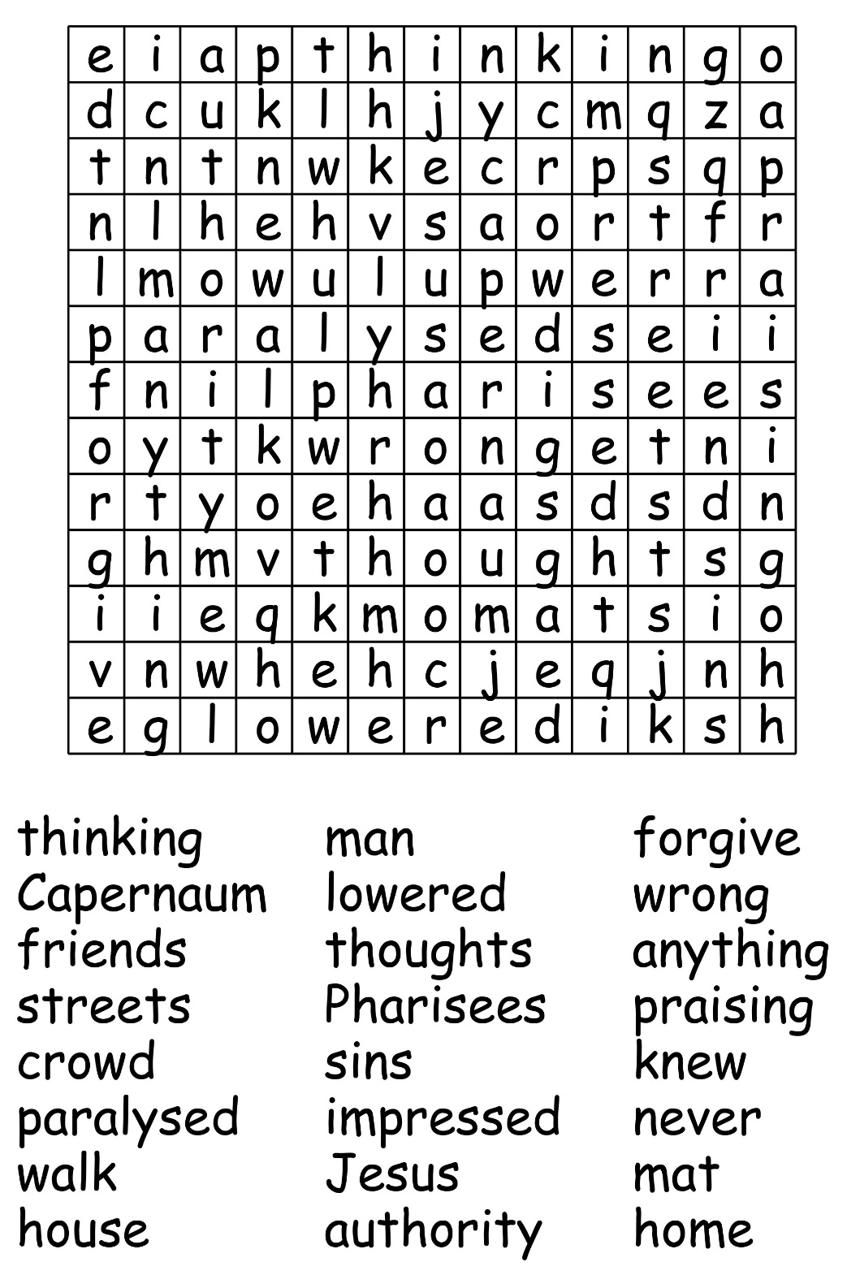

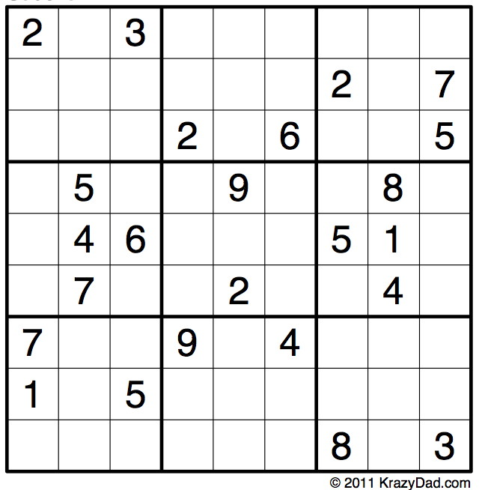

**Home Communion**

If you know of anyone who would like home communion please contact Julia (01946 830215)



***Parish Magazine***

Thank you to all distributors who deliver the parish magazine all through the year, in all weathers - your help is much appreciated.

[](https://www.google.co.uk/url?sa=i&rct=j&q=&esrc=s&source=images&cd=&ved=0ahUKEwilguzg897VAhUGzRQKHXQuDcMQjRwIBw&url=http://www.educationabroadasia.com/phuket-film-club/&psig=AFQjCNFPZmYyFXnPMAEKt2dySpwjB7KTzA&ust=1503081015770757)[](https://www.google.co.uk/url?sa=i&rct=j&q=&esrc=s&source=images&cd=&cad=rja&uact=8&ved=0ahUKEwj33uyl897VAhUE7BQKHaIuBrQQjRwIBw&url=http://www.sjsb.co.uk/extra-curricular/film-club/&psig=AFQjCNFPZmYyFXnPMAEKt2dySpwjB7KTzA&ust=1503081015770757) **Film Club**

Next Film Club Evening is Friday 21st June at 7pm at Harrington. There is no charge to either join the club or view films but a suggested donation of £2 for each film you watch would be great. This is just to cover our costs and will include tea, coffee or juice.  If you would like to bring your own wine we will provide glasses. Film club is open to anyone over the age of 18.

**Men’s breakfast**

**If you like good company, good food and a good chat then men’s breakfast is right up your street. We meet at the Galloping Horse usually on the last Saturday of the month at 9.30am. If you want to know more give Ron Hill a call (830072)**