|  |  |
| --- | --- |
| **E. LAMB AND SON**  ***Est. 1944***  ***Spares / Appliances***  ***Solid Fuels Bottled Gas***  **Tel: 01946 830353** | **Lynda Elliot**  **Hairdresser**  **C:\Users\Barbara Lamb\AppData\Local\Microsoft\Windows\Temporary Internet Files\Content.IE5\06JCVCET\MC900324786[2].wmf**  **Tel: 01946 830504**  **Mobile: 07798 648233** |
| **YEOWART, GILL AND RUDD**  **Chapel of Rest, Low Monkwray**  **Prop: John, David & Margaret Yeowart**  The Family funeral service  People committed to a dignified service at the lowest cost  GOLDEN CHARTER  Pre-paid Funeral Plan  Details available on request  **Tel: 01946 693819/692939**  **(24 hours)**  **Beware of recommendations that could be costly!!** | **TOM EDGAR**  **Funeral Services**  Caxton House, 13 Brow Top  Workington, CA14 2DP  Private Chapels of Rest  Tel: 01900 603388  Email: tom.edgar1@btconnect.com  **24 HOUR SERVICE** |



**Church of the Holy Spirit**

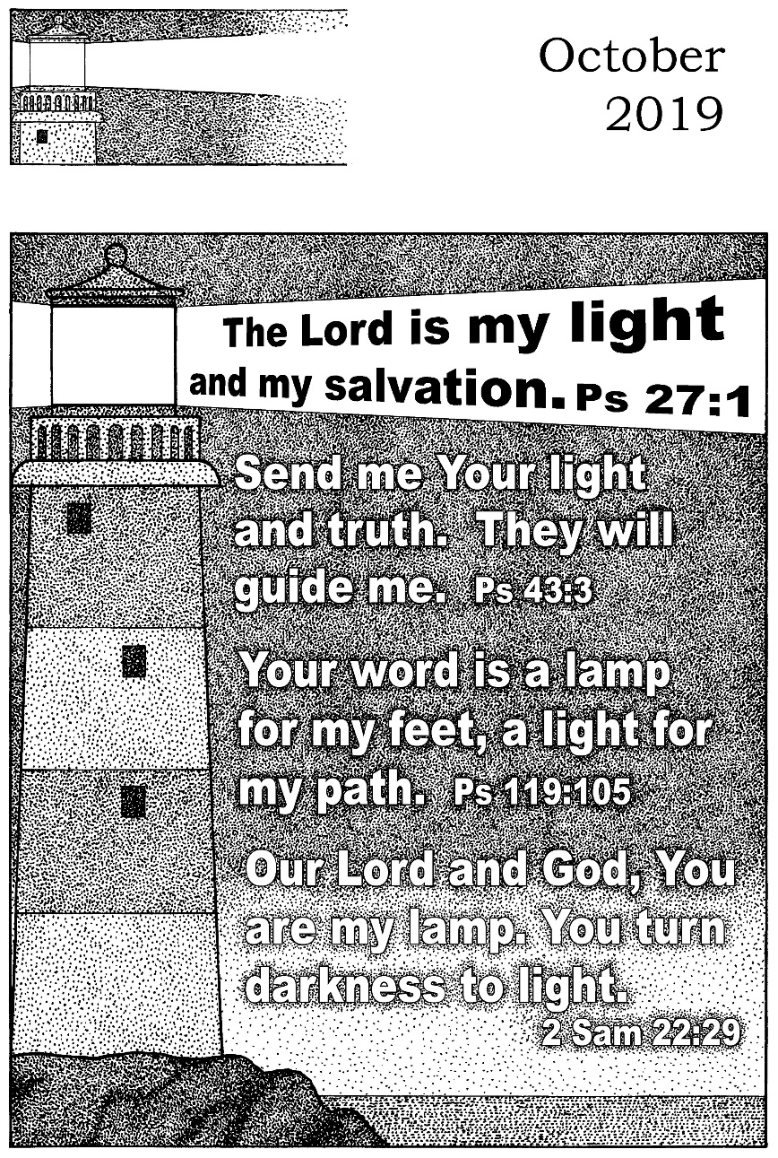

**Parish Magazine**

**What’s on in the village?**

**All of the following activities take place in the Community Centre. For further details please telephone 01946 834297**

**Baby & Toddler Group:** Every Wednesday (Term Time) 10am

**Lunch Club:** 2nd Friday of the month at 12 noon

**Family and Local History:** Every third Tuesday from 7 - 9 pm

**Art Class**: Most Tuesdays from 6.15 – 8.15 pm

**Craft Club**: Every Tuesday from 1 - 3 pm

**Evergreens**: Thursdays from 1 – 3 pm

**Reading Group:** Every second Monday from 2 pm (in the Library)

**Knit and Knatter:** Every Friday from 1 -3 pm

**“Old Folks” Bingo**: Every Monday at 8 pm

**Fit 4 Life**: Every Tuesday from 11 – 12.15 am

**Parish Council** meets every second Monday at 7 pm in the Club for Young People

**Mothers Union**: every first Wednesday in the month at 7 pm in the Community Centre

**Distington Club for Young People**: if you require further information please contact Christine on 832882

-o-o-o-o-o-o-o-o-o-o-o-o-o-o-o-o-o-o-o-o-o-o-o-o-o-o-o-o-o-o-o-



|  |  |
| --- | --- |
|  | **John Sandelands Funeral Directors Ltd**  **Tel: 01900 602753**  **Rest Chapels at;**  Main Road, Seaton  South William St, Workington  Bridge Street, Cockermouth |

**Wall & Tree Cockermouth**

* **Hedge & Tree maintenance & removals**
* **Grass Cutting, garden tidying & clearances**
* **Small landscaping projects**
* **Fence installation, painting & repair**
* **Firewood & chainsaw work**
* **General garden D.I.Y.**

**We can work within your budget**

**Contact Dale for a no obligation quotation**

**Tel. 01900 828947 mob 07907 225 316**

**E-mail moose.moore@live.co.uk**

**THE CHURCH OF THE HOLY SPIRIT, DISTINGTON**

**Rector: Revd. Julia Powley, The Rectory, Rectory Close, Harrington, Workington, CA14 5PN Tel: 01946 830215**

**Churchwardens Marlene Pettit**

**Lay Chair Doreen Belford**

**Secretary Barbara Lamb**

**Treasurer Doreen Belford**

**Electoral Roll**

**Officer Barbara Lamb**

**PCC Members as above plus**

**Helen Finn, Julia Hoggarth, Nicola Stephenson, Pat Nelson, Rhoda Robinson, Ray Bailey & Rosalind Brough**

**Sides Persons Myra Allen, Ann Blakemore, Joan, Milligan, Rosalind Brough, Sandra Parry, Brenda Bailey & Pat Nelson**

|  |  |  |
| --- | --- | --- |
| **For any information needed about Baptisms, Weddings or Funerals please contact**  **Revd. Julia Powley Tel: 01946 830215** | | |
| **Triple TTT Ltd**  **The Old Job Specialists doing the Jobs you hate**  ***Window cleaning – power spraying***  ***Guttering – painting – brick laying***  **Van Hire with Driver, fully insured – mini removals**  ***Grasscutting – tree pruning – hedge cutting***  ***Commercial and household cleaning***  **COMPETITIVE QUOTES**  **01900 810008**  **07934 770328** | **Advertise Here?**  **Find out more about our great yearly rates**  **for more information, contact**  **Barbara Lamb**  **07425 792 995** |
| **Brockbank Curwen Cain and Hall**  Solicitors and Notaries  44 Duke Street  Whitehaven CA28 7NR  Tel: 01946 692195  Also at Cockermouth, Maryport, Workington and Keswick   * **Home Information Packs** * **Residential and Commercial Conveyancing** * **Wills and Probate** * **Court of Protection** * **Personal Injury** * **Matrimonial** * **Crime** * **Employment**   www.brockbanks.co.uk | **DISTINGTON**  **COMMUNITY CENTRE**  **The Centre runs training events and other community activities including public meetings. The Mabel Knowles room is a committee room available for small meetings – capacity 25. The Main hall is available for events, activities, and private parties etc. – capacity 100.**  **Full kitchen available**  **For further details**  **tel: 01946 834297** |

**Flowers**

Do you have loved ones who you like to remember with flowers?

Did you know you can display flowers in memory of your loved ones in church?

These can be displayed on the altar or throughout the church.

**For more information please speak to**

**Nicola Stephenson on 07933551524.**

**Church Memorial Book**

If anyone would like to have their loved one’s details added to our memorial book in Church, please speak with Julia Powley.

There will be a small charge of £5 per name

Dear everyone,

Welcome to the month of harvest, when we remember God’s goodness to us in the provision of our food, and also remember the satisfaction of farmers and growers reaping the results of their hard work. As someone with a very neglected vegetable patch, I find great delight in picking the few vegetables that have managed to survive my neglect this year.

Harvest reminds us that in order to get a crop, we need to sow seeds. It also reminds us that we will only harvest courgettes if we sow courgettes. No point in sowing dandelions and expecting sunflowers.

But then, that applies in so many areas of life, doesn’t it? As I am writing this, our MPs are embroiled in a heated and turbulent debate in which people are using offensive language and threatening fellow MPs. It is hard to expect young people to treat each other with respect and to tolerate different opinions well when those who lead our country cannot do that.

Whatever happens in the coming weeks over the Brexit issue, our country is divided, and the divisions are becoming wider and generating more hatred than we have seen in many years. At this time of harvest, we are reminded that there is another harvest, apart from the physical one. The other harvest is spiritual, the fruit of the Spirit, where we harvest love, joy, peace, patience, kindness, goodness, faithfulness, gentleness and self-control. How we need those qualities now in our country, our communities and our churches. But we will only harvest what we sow.

I pray that in this harvest month, we will allow the Spirit to plant seeds in us, that we might harvest the characteristics which will bring hope and healing and restore order in our society today.

Julia

The Church of the Holy Spirit warmly invites you to our…

**Baby and Toddler Group**

Distington Community Centre

Every Wednesday in school term time

10am start

Babies and toddlers with their parents/carers are welcome

£1 per family

For more information please contact Julia Hoggarth on 07747581390

**No Toddlers on 23rd October 2019**

**Lunch Club**

Monthly on the 2nd Friday 12noon - 2pm

Next one is;

**11th October 2019**

Distington Community Centre

Beautiful food served at fantastic prices

One, two or three courses with tea & coffee

**Your Church Needs You!**

* To go on the rota to read a lesson
* To go on the list to lead prayers
* To go on the cleaning rota
* To go the rota to print the magazine
* To be a sidesperson
* To be a member of the PCC

If you can help, please speak with

Julia Powley

**From the Parish Registers**

**Funerals**

May they Rest in Peace

**Audrey Harrison**

Age 80 years

Died 23rd July 2019

Funeral 1st August 2019

**Website**

We have a new website for the United Benefice which covers the activities of both St Mary’s Harrington and The Holy Spirit Distington. The website is still in development, so we are looking for comments and ideas to include. Have a look and tell either James Mossop or Andrew Callaway (me!) what you think. The web address is [www.stmarys-harrington-and-holyspirit-distington.co](http://www.stmarys-harrington-and-holyspirit-distington.co) If you want to email your thoughts my email address is [a.callaway@talktalk.net](mailto:a.callaway@talktalk.net)

Thanks Andrew

**CHURCH CLEANING ROTA**

**OCTOBER 2019**

6th Julia & Helen

15th Lynda & Ann

22nd Sandra & Trudy

29th Katrina & Carl

November 3rd Julia & Helen

If you are unable to make the week you are due to clean, please let Sandra know on 01946 830046.

|  |  |  |  |  |
| --- | --- | --- | --- | --- |
|  | **READINGS** | **READER** | **SIDESPERSON** | **FLOWERS** |
| **06th October** | **Leviticus 23 vs 33 - 34 & 39 - 43 John 7 vs 37 - 44** | **Children’s Church** | **Barbara Lamb Brenda Bailey** | **Eileen Weighman** |
|
| **13th October** | **2 Timothy 1 vs 1 - 14 Luke 17 vs 5 - 10** | **Ray Rector** | **Barbara Lamb Brenda Bailey** | **Mrs Christopherson** |
|
| **20th October** | **2 Timothy 3 vs 14 - 4 vs 5 Luke 18 vs 1 - 8** | **Julia H Rector** | **Sandra Parry Ann Blakemore** | **Mrs Christopherson** |
|
| **27th October** | **Romans 15 vs 1 - 6 Luke 4 vs 16 - 24** | **Sandra Rector** | **Sandra Parry Ann Blakemore** | **Rhoda Robinson** |
|

|  |  |
| --- | --- |
| **OCTOBER** | |
| **Date** | **Event** |
| Wed 02/10/2019 | 9.30am - Holy Communion 10am - Toddler Group in Community Centre |
| Thu 03/10/2019 | 12.30 - Soup and sarnies with Cockermouth Ukulele Band in the Chapel |
| Sun 06/10/2019 | 9.15am - Harvest Festival |
| Tue 08/10/2019 | 7pm - Harvest Supper and auction in the Community Centre |
| Wed 09/10/2019 | 9.30am - Holy Communion 10am - Toddler Group in Community Centre |
| Sun 13/10/2019 | 9.15am - Holy Communion 7pm - Study group at Harrington Rectory |
| Wed 16/10/2019 | 9.30am - Holy Communion 10am - Toddler Group in Community Centre |
| Sat 19/10/2019 | 4pm - Messy Marys in Harrington Church Hall |
| Sun 20/10/2019 | 3pm - Church in the Afternoon |
| Wed 23/10/2019 | 9.30am - Holy Communion |
| Sun 27/10/2019 | 9.15am - Holy Communion 7pm - Study Group |
| Wed 30/10/2019 | 9.30am - Holy Communion 10am - Toddler Group in Community Centre |
| Fri 01/11/2019 | 7pm - Chocolate Bingo |
| Sun 03/11/2019 | 3pm - Memorial Service |

**100 CLUB  
It’s that time again – time to enter the 100 Club draw.**

**Were you a winner last year?** **No**, well it **MUST** be your turn this time. Remember you must be in it to win.

The cost of a number is £12.00 for the year. If we have 60 people entering the prize money would be £30.00 and the remaining £30.00 would go to Church funds.

If you are interested, please complete the slip below and return it to any member of the PCC along with your £12.

- - - - - - - - - - - - - - - - - - - - - - - - - - - - - - - - - - - - - - - - - -

Name ………………………………………………………..

Address ………………………………………………………

……………………………………………………………………

Tel. No. …………………………………………………….



**Church of the Holy Spirit**

**  
HARVEST SUPPER**

**Tuesday 8th October**

**7 pm**

**DISTINGTON COMMUNITY CENTRE**

**Tickets £6 (children £3)**

**SOUP, SANDWICHES AND PUDDING**

**followed by Auction of Produce**

**Church of the Holy Spirit**

**CHOCOLATE**



**Friday 1st November**

**7pm**

**DISTINGTON COMMUNITY CENTRE**

**Jacket Potatoes and Cakes**

**Tickets £6 (children £3)**

**ALL WELCOME**

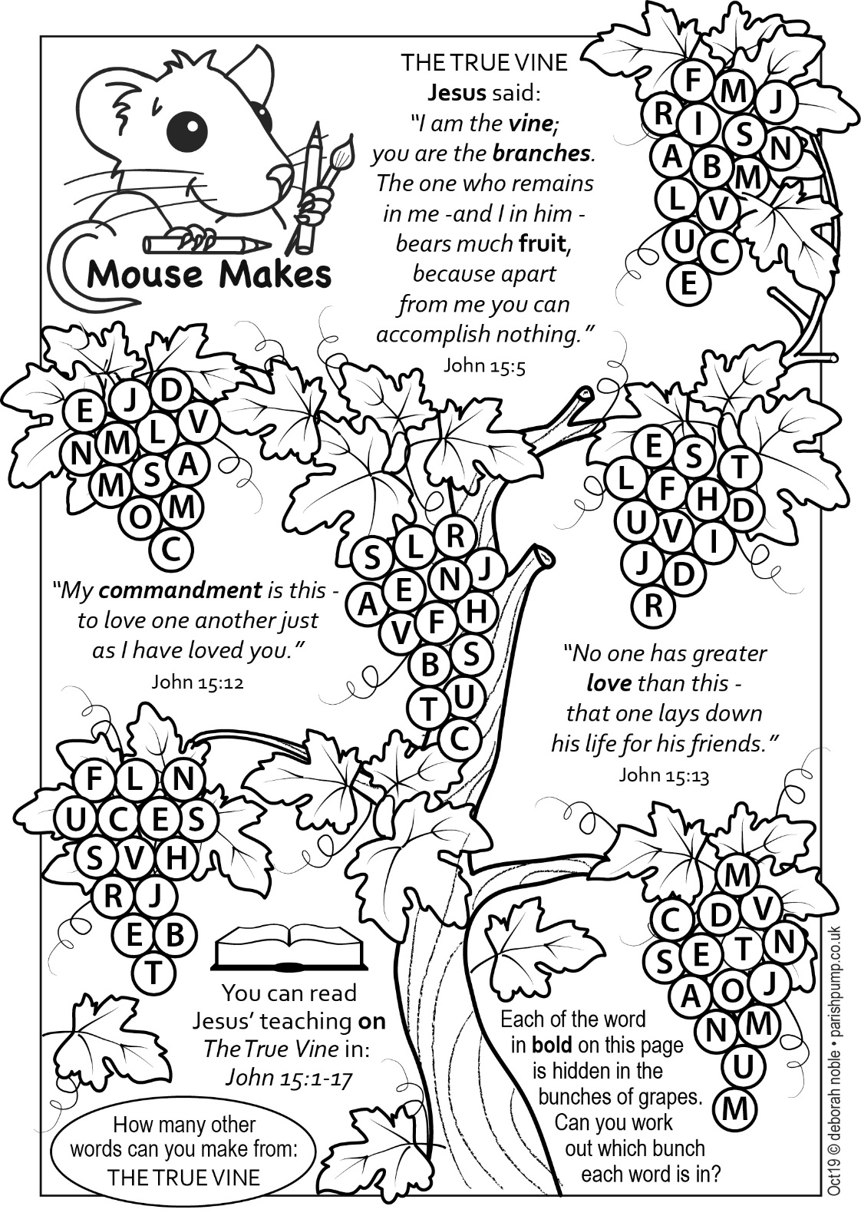

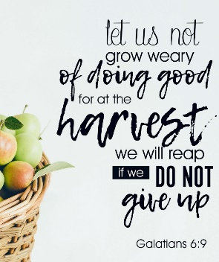

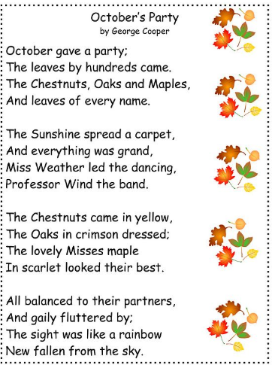

**Future Dates for your Diary!**

**Memorial Service**

3rd November 2019 3pm in Church

**Chocolate Bingo**

1st November 2019 in Community Centre

**Christmas Fair**

24th November 2019 12noon in Community Centre

**Christingle**

10th December 2019 6pm in Church

**Distington School Carol Service**

20th December 2019 9.15am in Church

**Carols by Candlelight**

22nd December 2019 4pm in Church

**Crib Service**

24th December 2019 5.30pm in Church

**Midnight Mass**

24th December 2019 11.30pm in Church

**Church of England claims Hallowe'en is 'similar' to Christmas Eve**

Hallowe'en is a special religious festival just like Christmas Eve, according to the Church of England.

A website created by the Church claims that the event, which is based on a pagan celebration and has no Biblical basis, represents "light coming in the darkness" similar to the arrival on Earth of Jesus Christ.

It is part of a campaign by clergy to stop the spread of the secular American interpretation of Hallowe'en that sees children dress in horror masks and demand "trick or treat" from neighbours and revive its Christian meaning of a commemoration of saints.

However, critics claimed it is "odd" for the Church to be equating the two festivals.

