|  |  |
| --- | --- |
| **E. LAMB AND SON**  ***Est. 1944***  ***Spares / Appliances***  ***Solid Fuels Bottled Gas***  **Tel: 01946 830353** | **Lynda Elliot**  **Hairdresser**  **C:\Users\Barbara Lamb\AppData\Local\Microsoft\Windows\Temporary Internet Files\Content.IE5\06JCVCET\MC900324786[2].wmf**  **Tel: 01946 830504**  **Mobile: 07798 648233** |
| **YEOWART, GILL AND RUDD**  **Chapel of Rest, Low Monkwray**  **Prop: John, David & Margaret Yeowart**  The Family funeral service  People committed to a dignified service at the lowest cost  GOLDEN CHARTER  Pre-paid Funeral Plan  Details available on request  **Tel: 01946 693819/692939**  **(24 hours)**  **Beware of recommendations that could be costly!!** | **TOM EDGAR**  **Funeral Services**  Caxton House, 13 Brow Top  Workington, CA14 2DP  Private Chapels of Rest  Tel: 01900 603388  Email: tom.edgar1@btconnect.com  **24 HOUR SERVICE** |



**Church of the Holy Spirit**



**Parish Magazine**

**What’s on in the village?**

**All of the following activities take place in the Community Centre. For further details please telephone 01946 834297**

**Baby & Toddler Group:** Every Wednesday (Term Time) 10am

**Lunch Club:** 2nd Friday of the month at 12 noon

**Family and Local History:** Every third Tuesday from 7 - 9 pm

**Art Class**: Most Tuesdays from 6.15 – 8.15 pm

**Craft Club**: Every Tuesday from 1 - 3 pm

**Evergreens**: Thursdays from 1 – 3 pm

**Reading Group:** Every second Monday from 2 pm (in the Library)

**Knit and Knatter:** Every Friday from 1 -3 pm

**“Old Folks” Bingo**: Every Monday at 8 pm

**Fit 4 Life**: Every Tuesday from 11 – 12.15 am

**Parish Council** meets every second Monday at 7 pm in the Club for Young People

**Mothers Union**: every first Wednesday in the month at 7 pm in the Community Centre

**Distington Club for Young People**: if you require further information please contact Christine on 832882

-o-o-o-o-o-o-o-o-o-o-o-o-o-o-o-o-o-o-o-o-o-o-o-o-o-o-o-o-o-o-o-

|  |  |
| --- | --- |
|  | **John Sandelands Funeral Directors Ltd**  **Tel: 01900 602753**  **Rest Chapels at;**  Main Road, Seaton  South William St, Workington  Bridge Street, Cockermouth |

**Wall & Tree Cockermouth**

* **Hedge & Tree maintenance & removals**
* **Grass Cutting, garden tidying & clearances**
* **Small landscaping projects**
* **Fence installation, painting & repair**
* **Firewood & chainsaw work**
* **General garden D.I.Y.**

**We can work within your budget**

**Contact Dale for a no obligation quotation**

**Tel. 01900 828946 mob 07907 225 316**

**E-mail moose.moore@live.co.uk**

**THE CHURCH OF THE HOLY SPIRIT, DISTINGTON**

**Rector: Revd. Julia Powley, The Rectory, Rectory Close, Harrington, Workington, CA14 5PN Tel: 01946 830215**

**Churchwardens Marlene Pettit**

**Lay Chair Doreen Belford**

**Secretary Barbara Lamb**

**Treasurer Doreen Belford**

**Electoral Roll**

**Officer Barbara Lamb**

**PCC Members as above plus**

**Helen Finn, Julia Hoggarth, Nicola Stephenson, Pat Nelson, Rhoda Robinson, Ray Bailey & Rosalind Brough**

**Sides Persons Myra Allen, Ann Blakemore, Joan, Milligan, Rosalind Brough, Sandra Parry, Brenda Bailey & Pat Nelson**

|  |  |  |
| --- | --- | --- |
| **For any information needed about Baptisms, Weddings or Funerals please contact**  **Revd. Julia Powley Tel: 01946 830215** | | |
| **Triple TTT Ltd**  **The Old Job Specialists doing the Jobs you hate**  ***Window cleaning – power spraying***  ***Guttering – painting – brick laying***  **Van Hire with Driver, fully insured – mini removals**  ***Grasscutting – tree pruning – hedge cutting***  ***Commercial and household cleaning***  **COMPETITIVE QUOTES**  **01900 810008**  **07934 770328** | **Advertise Here?**  **Find out more about our great yearly rates**  **for more information, contact**  **Barbara Lamb**  **07425 792 995** |
| **Brockbank Curwen Cain and Hall**  Solicitors and Notaries  44 Duke Street  Whitehaven CA28 7NR  Tel: 01946 692195  Also at Cockermouth, Maryport, Workington and Keswick   * **Home Information Packs** * **Residential and Commercial Conveyancing** * **Wills and Probate** * **Court of Protection** * **Personal Injury** * **Matrimonial** * **Crime** * **Employment**   www.brockbanks.co.uk | **DISTINGTON**  **COMMUNITY CENTRE**  **The Centre runs training events and other community activities including public meetings. The Mabel Knowles room is a committee room available for small meetings – capacity 25. The Main hall is available for events, activities, and private parties etc. – capacity 100.**  **Full kitchen available**  **For further details**  **tel: 01946 834297** |

**Flowers**

Do you have loved ones who you like to remember with flowers?

Did you know you can display flowers in memory of your loved ones in church?

These can be displayed on the altar or throughout the church.

**For more information please speak to**

**Nicola Stephenson on 07933551524.**

**Church Memorial Book**

If anyone would like to have their loved one’s details added to our memorial book in Church, please speak with Julia Powley.

There will be a small charge of £5 per name

Dear friends,

I hope that you have had a good summer, with plenty of sunshine in between the showers. September sees everything starting back again, from schools to uniformed organisations to toddlers. The challenge we have is whether this year will be the same as last or whether we can somehow make it better. I don’t mean politically (very much out of our hands) or even environmentally (though we can all do our bit there). I just mean in little ways in our relationships with each other.

In 1 Corinthians 13, the apostle Paul gives us a definition of love which include the words “Love is kind”. Our world is not always kind. Social media encourages folk to say just what they think, regardless of the effect it is going to have. Bullying is rife, in many different situations and age groups. But kindness can cost us nothing and make a huge difference.

Here is a little way in which we can do that, a way I discovered from social media! Next time we say “I’m sorry I’m late”, add on “thank you for waiting for me”. Next time we say “I’m sorry but I can’t make it tonight”, add on “thank you for inviting me”. Next time we say “I’m sorry for being emotional” add on “thank you for loving me”. I’m sure you can think of lots more examples.

What might the effect be? That we turn a critical culture, where there is always the need to apologise, into a culture where folk are accepted and grateful, and where there is an atmosphere of being appreciated and valued. That, my friends, is one very important aspect of Christian love.

With love,

Julia

The Church of the Holy Spirit warmly invites you to our…..

**Baby and Toddler Group**

Distington Community Centre

Every Wednesday in school term time

10am start

Babies and toddlers with their parents/carers are welcome

£1 per family

For more information please contact Julia Hoggarth on 07747581390

**TODDLERS STARTS BACK ON**

**11TH SEPTEMBER**

**Lunch Club**

Monthly on the 2nd Friday 12noon - 2pm

Next one is;

**13th September 2019**

Distington Community Centre

Beautiful food served at fantastic prices

One, two or three courses with tea & coffee

**Your Church Needs You!**

* To go on the rota to read a lesson
* To go on the list to lead prayers
* To go on the cleaning rota
* To go the rota to print the magazine
* To be a sidesperson
* To be a member of the PCC

If you can help, please speak with

Julia Powley

**From the Parish Registers**

**Funerals**

May they Rest in Peace

**Doreen Rourke**

Age 82 years

Died 28th May 2019

Funeral 4th June 2019

**Miles Bawden**

Age 82 years

Died 21st May 2019

Funeral 6th June 2019

**Florence Konieczny**

Age 86 years

Died 23rd July 2019

Funeral 29th July 2019

**From the Parish Registers**

**Baptisms**

We welcome by Baptism into the Lords Family

**Keagen Hodgson**

Born 31st March 2019

Baptised 23rd June 2019

**Alyssia Sewell-Fulton**

Born 19th July 2017

Baptised 23rd June 2019

**Henry-Parker Hutton**

Born 13th July 2018

Baptised 14th July 2019

**CHURCH CLEANING ROTA**

**SEPTEMBER 2019**

1st Katherine & Carl

8th Julia & Helen

15th Lynda & Ann

22nd Sandra & Trudy

29th Katrina & Carl

October 6th Julia & Helen

If you are unable to make the week you are due to clean, please let Sandra know on 01946 830046.

**Website**

We have a new website for the United Benefice which covers the activities of both St Mary’s Harrington and The Holy Spirit Distington. The website is still in development, so we are looking for comments and ideas to include. Have a look and tell either James Mossop or Andrew Callaway (me!) what you think. The web address is [www.stmarys-harrington-and-holyspirit-distington.co](http://www.stmarys-harrington-and-holyspirit-distington.co) If you want to email your thoughts my email address is [a.callaway@talktalk.net](mailto:a.callaway@talktalk.net)

Thanks Andrew

|  |  |  |  |  |
| --- | --- | --- | --- | --- |
|  | **READINGS** | **READER** | **SIDESPERSON** | **FLOWERS** |
| **1st September** | **Hebrews 13 vs 1 - 8 and 15 - 16 Luke 14 vs 1 and 7 - 14** | **Childrens Church** | **Barbara Lamb Brenda Bailey** | **Blanche Lamb** |
|
| **8th September** | **Philemon 1 - 21 Luke 14 vs 25 - 33** | **Ray Bailey Rector** | **Sandra Parry Ann Blakemore** | **Blanche Lamb** |
|
| **15th September** | **Exodus 32 vs 7 - 14 Luke 15 vs 1 - 10** | **Julia Hoggarth Rector** | **Sandra Parry Ann Blakemore** | **Julia Hoggarth** |
|
| **22nd September** | **Amos 8 vs 4 - 7 Luke 16 vs 1 - 13** | **Sandra Parry Rector** | **Rosalind Brough Pat Nelson** | **Julia Hoggarth** |
|
| **29th September** | **Revelation 12 vs 7 - 12 John 1 vs 47 - 51** | **Doreen Belford Rector** | **Rosalind Brough Pat Nelson** | **Eileen Weightman** |
|

**The Robin**

Long before my clock alarms  
I hear the robin as he charms  
A sleeping world with glorious song.  
But he sings loud, and he sings long,  
And, as I rub my sleepy eyes  
Long before I’m meant to rise  
I wish that he would use his beak  
Instead the early worm to seek!

**100 CLUB  
It’s that time again – time to enter the 100 Club draw.**

**Were you a winner last year?** **No**, well it **MUST** be your turn this time. Remember you must be in it to win.

The cost of a number is £12.00 for the year. If we have 60 people entering the prize money would be £30.00 and the remaining £30.00 would go to Church funds.

If you are interested, please complete the slip below and return it to any member of the PCC along with your £12.

- - - - - - - - - - - - - - - - - - - - - - - - - - - - - - - - - - - - - - - - - -

Name ………………………………………………………..

Address ………………………………………………………

……………………………………………………………………

Tel. No. …………………………………………………….



**CHURCH OF THE HOLY SPIRIT**

**COFFEE MORNING**



**Saturday 14th September**

**10 am – 11.30 am**

**THE OLD CHAPEL**

**MAIN STREET**

**EVERYONE WELCOME**

|  |  |
| --- | --- |
| **SEPTEMBER** | |
| **Date** | **Event** |
| Sun 01/09/2019 | 9.15am - Holy Communion |
| Wed 04/09/2019 | 9.30am - Holy Communion |
| Sun 08/09/2019 | 9.15am - Family Worship 6pm - Healing Eucharist at Harrington |
| Wed 11/09/2019 | 9.30am - Holy Communion 10am - Toddlers starts back |
| Fri 13/09/2019 | 7pm - Film Club in Harrington Church Hall |
| Sat 14/09/2019 | 10am - Coffee Morning in the Old Chapel |
| Sun 15/09/2019 | 3pm - Church in the Afternoon 7pm - Study Group |
| Wed 18/09/2019 | 9.30am - Holy Communion 10am - Toddler Group in Community Centre 7.30pm - PCC Meeting |
| Sat 21/09/2019 | 4pm - Messy Marys in Harrington Church Hall |
| Sun 22/09/2019 | 9.15am - Holy Communion |
| Wed 25/09/2019 | 9.30am - Holy Communion 10am - Toddler Group in Community Centre |
| Sat 28/09/2019 | Vision Day for Workington Mission Community |
| Sun 29/09/2019 | 9.15am - Holy Communion 7pm - Study Group |

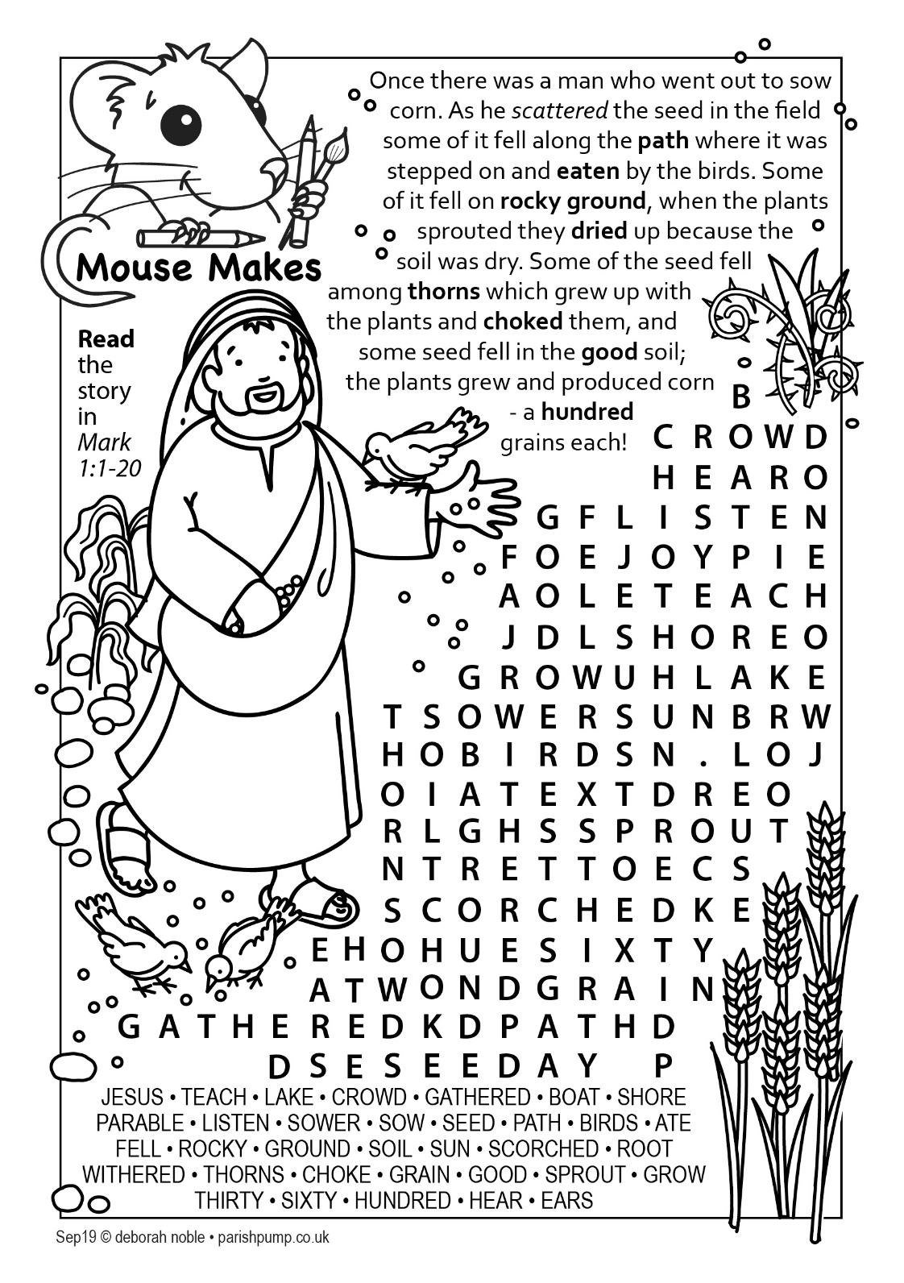

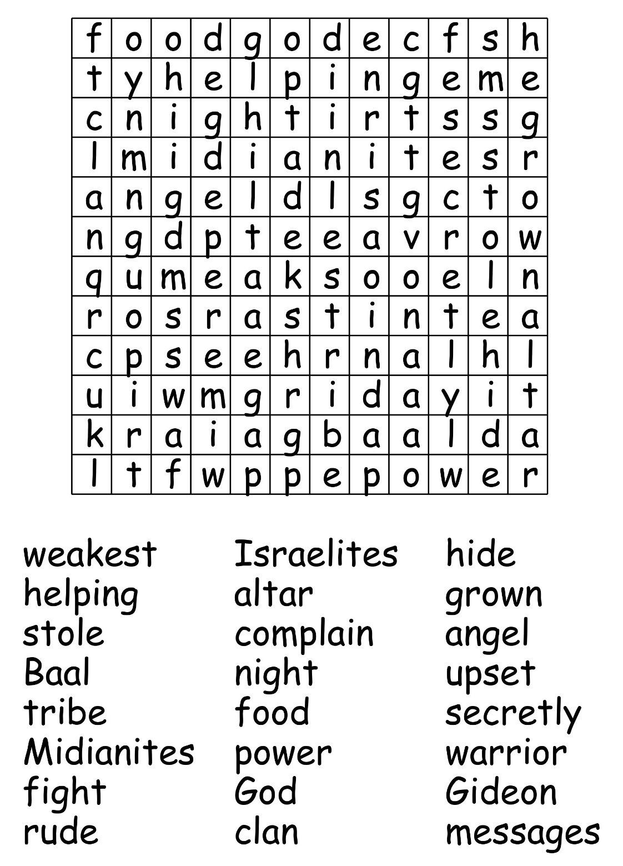

**Making the most of your time**

September is the time of year when we get back to normal routine after the summer break. It’s an opportunity to ask how God wants us to make the most of the time He gives us. Although we can’t always choose how we use our time, we can control our attitude towards it. How can we use our time wisely?

Firstly, see time is a gift from God. Each day is an opportunity to know God better and serve Him. Time isn’t inexhaustible, as someday our time on earth will end. ‘Teach us to number our days, that we may gain a heart of wisdom.’ (Psalm 90:12). The first thing we can do when we awake is thank God for the gift of another day.

Secondly, commit your time to God. Time is not to be wasted, but to be used for God’s glory. We are accountable to God for the way that we use our time: ‘Be very careful, then, how you live – not as unwise but as wise, making the most of every opportunity’ (Ephesians 5:15,16). We should ask God to help us organise our time more wisely, to reflect His concerns.

Thirdly, set aside time for God, others and ourselves. How often can we go through a whole day without thinking about God or ignoring someone who needs our help? This is because we relegate God to our spare time, so He ends up at the bottom of our list of priorities. Jesus said, ‘Seek first His kingdom and His righteousness’ (Matthew 6:33). If we prioritise our time for God, people and our needs, the rest of life will fit around them.

*‘I have so much to do today that I shall spend the first three hours in prayer.’* (Martin Luther).