**The Parish of St. Mary,**

**Harrington with Salterbeck**



**November 2019**

**40p**

**St Mary’s Church**

Priest in Charge Rev Julia Powley 830215

Churchwardens Mr Ian Smith 831246

Mr Charles Murray 832507

PCC Vice-Chair Mrs Carol Callaway 833223

PCC Secretary Mrs Anne Falcon 0782 187 5509

PCC Treasurer Mrs Ann Brown 832384

Assistant Treasurer Mrs Carole Pattinson 830222

Our Website: New united benefice website! [www.stmarys-harrington-and-holyspirit-distington.co](http://www.stmarys-harrington-and-holyspirit-distington.co)

**Who to Contact**

**For Weddings, Baptisms, Funerals, House Communions, general enquiries or to arrange for somebody to be prayed for in church please contact Rev Julia Powley**

**Flowers in Church:** Marion Walker 834470

**Parish Magazine:** Andrew or Carol Callaway 833223

([a.callaway@talktalk.net](mailto:a.callaway@talktalk.net))

**Pew Sheet:** Ann Brown 832384

**Weekly Readings:** Susan Janulis 832653

[](http://images.google.com/imgres?imgurl=http://www.fotosearch.com/bthumb/ARP/ARP114/Phone_3.jpg&imgrefurl=http://www.fotosearch.com/illustration/dialing.html&usg=__D6wKw6FcmBvWkN8EqcouSrsUzfA=&h=145&w=170&sz=9&hl=en&start=12&tbnid=ewW80SF2DVHq8M:&tbnh=84&tbnw=99&prev=/images?q%3Dtelephone%2Bclip%2Bart%26gbv%3D2%26hl%3Den)

Dear everyone,

And so the year moves onwards, the nights drawn in and the adverts starting to tell us that we need to go crazy and spend all our money on Christmas. But before we get to that point, we have the season of remembering, the season when memorial service and remembrance service dominate the first half of the month. By the time you read this, we might even be out of the EU. It would be poignant if that happened at this time of year, when we remember the carnage caused when Europe was at loggerheads with itself.

On November 22nd in Keswick, there is a lecture at Keswick Methodist Church by a theologian called Anna Rowlands. The lecture is entitled: A Fractured Nation – Brexit and the Christian Vision of the Common Good. It is open to everyone though you need to book tickets. It is acknowledging that the Brexit debate has divided the nation and that, after the politics, we need those divisions to be healed if we are going to flourish together.

In my role, I see division at all levels, from within individual families to within communities and within the national church. Jesus told us that as church we are called to be one, but we have failed miserably on that front. Thankfully, the pressures facing the church today are drawing us back together, at least on a local level.

As we remember the cost of division for our nation and for individual families who lost their loved ones to war, I pray that we will find ways to heal the divisions of today, that families, communities and our nation might know reconciliation and peace. Because war comes at too high a cost, even within a family.

With love,

Julia

**MC900216560[1]Home Communion**

If you know of anyone who would like home communion please contact Julia (01946 830215)

**M.U. News**

At our October meeting we were introduced to Frank, Bertha and Shongoli who live in Malawi in central Africa. Deb Lee, Calder Deanery M.U. Leader had travelled to see what support Bishop James Harvest Appeal was all about; the Pigeon Pea Project. While we in the North of England feed pigeon peas, carlings, to racing pigeons in Malawi the peas are a staple food. They are a strong growing crop, very nutritious for family food with extra crop being sold with the money buying more food or seed for the next crop.

Bertha sells her peas through a co-operative group and now has money to buy school uniforms for her children at primary school.

Frank grows food for the family and has used some profit to buy shoes for his children and two goats for milk.

Shongoli, a widow, shares in a food garden with other women to provide for the village.

£5 buys enough pigeon peas to start a profitable small holding for each new farmer.

Deb showed a slide show of her photographs as she told us her story of her journey in Malawi. Our donations will fund another eleven pigeon pea farmers starting out.

**Dates to Remember**

Thursday 14th November – Festival Flowers night

Kitchen ladies for November:

Sue Wilkins, Elaine Rothery, Marion Walker & Marion Brasted

**Leprosy Mission Boxes**

Thank you to everyone who has been collecting for the Leprosy Mission this year. Can you please bring your boxes and had them in to Marion Walker.

**Thank you.**

**Our Regular Activities**

|  |  |  |
| --- | --- | --- |
|  | **Events (many of these activities only run during term time. Please use contact number for details)** | **Contact (all codes 01946 unless otherwise stated** |
| **Sunday** | **Services in Church** at 8.00am and 10.30am (for further details of services, see page 12).  **Go 4 It** during 10.30am service on 4th Sunday of the month  **Study Group** at 7pm on alternate Sunday evenings | Rev Julia Powley 830215  Ann 832384  Susan 832653  Rev Julia Powley  830215 |
| **Monday** | **Pram Club** 10 – 11.30am, Church Hall  **Explorer Scouts** 7.15 – 9.15pm, Scout Hut, East Avenue | Marion Walker  834470  Andrew Hardy  832810 |
| **Tuesday** | **Cubs** 6 – 7.30pm, Scout Hut  **Crafty Mary’s** 3rd Tuesday 7.00pm | Fiona Woodward 832506  Rev Julia Powley  830215 |
| **Wednesday** | **Beavers** 5.30-6.30pm, Scout Hut  **Scouts** 7 – 9pm, Scout Hut | John Fleming 833630  Andrew Brown 832384 |
| **Thursday** | **Holy Communion** 9.30am, Church  **Pram Club** 10 – 11.30am, Church Hall  **Choir Practice** 7 – 8pm, Church  **Mothers Union** (2nd Thursday of month) 7.00pm, Church Hall  **Youth Group** 7.15pm – 8.30pm  (alternate Thursdays) | Rev Julia Powley 830215  Carole Pattinson  830222  Ann Hill 830072  Audrey Armstrong 830507  Andrew Callaway  833223 |
| **Saturday** | **Messy Church –** (3rd Saturday of month**)** 4pm to 6pm, Church Hall  **Soup on Saturday** - (2nd Saturday of month) 11.30am – 1pm, Hall  **Men’s Breakfast** – (last Saturday of the month) 9.30am. | Rev Julia Powley  830215  Rev Julia Powley  830215  Ron Hill  830072 |

**From the Registers – September 2019**

**HOLY BAPTISM**

We give thanks to God for the gift of new life. We remember in our prayers those little ones who have recently been baptised:

j0335512

8th September – Noah Hodgson born 6/4/19

8th September - Karter Flynn born 4/2/19

15th September – Mia Relph born 22/5/19

15th September - Cleo Barker born 21/5/19

22nd September – Emilia Ainsworth born 2/3/19

22nd September – Grayson Smith born 16/5/19

29th September – Olivia Beddoe born 26/4/19

29th September – Koby Rickerby born 29/9/18

We pray for the parents and Godparents and their responsibility to bring up these children in the faith.

There were no funerals in September.

**FESTIVE FLOWER DISPLAY**

Thursday 14th November – 7.00pm in the Church Hall

Including refreshments and Raffle

£5.00 pay on the door

For more information call 01946 831241

**Readings for November**

3rd November    4th before Advent

Isaiah 1 vs 10 - 18    Luke 19 vs 1 - 10

                            Memorial Service

Psalm 42    John 11 vs 17 - 27

10th November     Remembrance

Micah 4 vs 1 - 5    John 15 vs 9 - 17

17th November    2nd before Advent

Malachi 4 vs 1 - 2a    Luke 21 vs 5 - 19

24th November    Christ the King

Colossians 1 vs 11 - 20 Luke 23 vs 33 - 43

**St Mary’s Church, Harrington – 250 Club**

 If you haven't already got your number but would like to be in the draw there are a few numbers left, please see Anne Falcon.

**September winners:**

1st 112 Dorothy hardy

2nd 140 Marjorie Rae

3rd 21 Brenda Cartmell

**October winners:**

1st 8 Julie Topping

2nd 81 Gordon Douglas

3rd 30 Hannah Mitchell

Thank you to everyone who supports the 250 Club.

A reminder that the half year subs are due, if you want to join in have a chat to Anne Falcon.

**Church Rota – November**

**Date** **Reader Prayers Sidespersons Chalice**

3rd Nov Graham Charles Pauline & Marion Mary Fr & Anne F

10th Nov Parade Service

17th Nov Sheila Ron Julie & Andrea Ann H & Muriel

24th Nov Mary Fr Carol Jacky & Kelly Leah & Charles

[](https://www.google.co.uk/url?sa=i&rct=j&q=&esrc=s&source=images&cd=&cad=rja&uact=8&ved=0ahUKEwie7-e8sN7VAhUFUBQKHQR-B4gQjRwIBw&url=http://www.clipartpanda.com/categories/cleaning-clip-art-for-free&psig=AFQjCNGtlcA0WyzFzwsd1qWZz6u_J3cO0w&ust=1503063080056030)**Church Cleaning – November**

2nd Nov – Pam Douglas & Julie Hardy

9th Nov – Marilyn Cowan & Phyllis Bell

16th Nov – Mary Francis & Pat Davies

23rd Nov – JackieMurray & Charles Murray

30th Nov – Andrea McTaggart

[](http://www.google.co.uk/url?sa=i&rct=j&q=&esrc=s&source=images&cd=&cad=rja&uact=8&docid=h3P92k1DFLkiUM&tbnid=ymBC3s0vFJBQAM:&ved=0CAUQjRw&url=http://www.colourbox.com/vector/cup-of-coffee-or-tea-vector-illustration-on-white-background-vector-2998457&ei=k-imU8P_F4akPdD4gcgI&bvm=bv.69411363,d.ZGU&psig=AFQjCNGylIaPwzYl-2NgvGruoCZykek-xQ&ust=1403533829002155)**Coffee Morning Rota – November**

3rd Nov – Julie & Sue

10th Nov – Marion & Muriel

17th Nov – Ann Brown & Susan

24th Nov – Leah & Pam

***If you can’t make any of these dates, please arrange a swap with someone.***

**Collections for September 2019**



1st - £167.60

8th - £95.00

15th - £116.00

22nd - £120.10

29th - £95.00

**Our thanks to those who continue to support us with their giving.**

Did you know that if you are a taxpayer, for every £1 donation you make to the Church we can claim 25p tax back from H M Revenue & Customs (at no extra cost to you). If you have not already signed a Gift Aid declaration please see Ann Brown for a form.

**Christmas Market**

Saturday 7th December from 12 – 3pm. Join us for hot turkey baguettes, mulled wine, hot chocolate, chocolate tombola, bottle tombola, cake stall, Christmas gifts, homemade jams and chutneys,  raffle and much more – we may even have a visit from Santa!  If you would to help make jams, chutneys or Christmas gifts etc to sell and would like some ideas please see either Ann Brown or Julia.

Thank you.

**Children’s Society Coordinator**

After many years Carole Pattinson has decided to stepdown from her role as our Children’s Society Co-ordinator. If you think you could fill this role please have a chat with Carole to see what the job involves. Thanks to Carole for all her hard work over the years.

**Harvest supper 2019**

A big thank you to everyone who came and made this a very successful evening, we made £343 which will be divided between Church and the Bishop's Harvest Appeal.

**5p collection**

Have you been into church recently?

We are now collecting panes for the next window, in the next couple of weeks we will be colouring the panes already purchased.

In October we raised £21.90.

Along with the Galloping Horse and Bookstall this makes a monthly total of £33, buying three more panes.

Thanks Carol.

**Important Dates – November 2019**

Saturday 1st Chocolate Bingo 7.00pm

at Distington Community Centre

Sunday 3rd Holy Communion 8.00am

Holy Communion 10.30am

**Memorial service 6.00pm**

**For those whom we love but no longer see**

Thursday 7th Holy Communion 9.30am

Choir practice 7.00pm

Saturday 9th  **Soup on Saturday 11.30am - 1.00pm**

**Followed by Book Club**

Sunday 10th Holy Communion 8.00am

**Remembrance Service 10.00am**

Healing service 6.00pm

Study group 7.00pm

Thursday 14th Holy Communion 9.30am

Mothers Union 7.00pm

Saturday 16th **Messy Mary’s 4.00 – 6.00pm**

Sunday 17th Holy Communion 8.00am

Holy Communion 10.30am

Tuesday 19th Crafty Mary’s 7.00pm

Thursday 21st Holy Communion 9.30am

Choir practice 7.00pm

Sunday 24th Holy Communion 8.00am

Holy Communion & **Go for it** 10.30am

**Christmas Fayre at Distington 12.00 – 2.00pm**

**Important Dates – November 2019 cont.**

Thursday 27th Holy Communion 9.30am

Choir practice 7.00pm

Friday 29th Film Club 7.00pm

Saturday 30th Men’s breakfast 9.30am

Study group will be on Sunday 1st December at 7.00pm.

**Soup on Saturday**

**[](http://www.google.co.uk/url?sa=i&rct=j&q=&esrc=s&frm=1&source=images&cd=&cad=rja&docid=5uivsYii7L8sRM&tbnid=i1DJjFjs1ejO2M:&ved=0CAUQjRw&url=http://griggstownfarm.com/food-of-the-week/food-of-the-week-soup-4/&ei=ZDQGU8usAsfL0AX88oCADQ&bvm=bv.61725948,d.ZG4&psig=AFQjCNGal-I_dPHLRYQjePg0hdXLaTkWRA&ust=1393001927748727)At St Mary’s Parish Church Hall, Harrington**

[](http://www.google.co.uk/url?sa=i&rct=j&q=&esrc=s&frm=1&source=images&cd=&cad=rja&docid=5uivsYii7L8sRM&tbnid=i1DJjFjs1ejO2M:&ved=0CAUQjRw&url=http://griggstownfarm.com/food-of-the-week/food-of-the-week-soup-4/&ei=ZDQGU8usAsfL0AX88oCADQ&bvm=bv.61725948,d.ZG4&psig=AFQjCNGal-I_dPHLRYQjePg0hdXLaTkWRA&ust=1393001927748727)**Good Food and Good Company**

**Saturday 9th November 11.30am – 1pm**

**ALL WELCOME**

Come and join us for a bowl of delicious homemade soup, a bread roll and a cup of tea/coffee all for just £2.00 – we do hope you can join us and we guarantee a warm welcome to all.

**Christian Bookstall**

We are going to have an area in the Lady Chapel for our Bibles and books. At the moment we are selling good quality second hand books and have made nearly £10 for the church window appeal. Once we have a new area I will be bringing New books and if there is time Christian Christmas cards and small gifts.

Come along and have a look – you may see something that you would like. For more information talk to Carol Callaway.

**Bishop’s Teaching Day 2019**

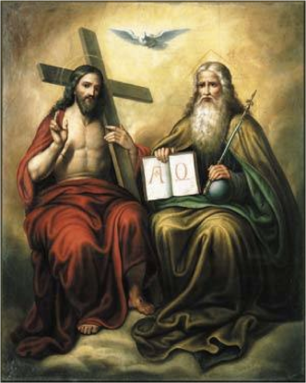

**This teaching day is part of our programme for ‘Growing Disciples’. Previous days have looked at the Gospel, The Bible, Prayer, Mission, The Church, the Kingdom of God, Evangelism, the Sermon on the Mount and The Old Testament, What is Discipleship?, Christian Lifestyle and What is Human?**

**This year Bishop James will continue the ‘What is…?’ series with an in depth look at ‘What is Church History?’.**

**‘What is Church History?’ will be offered in four locations (Barrow, Penrith, Workington and Carlisle).**

**Each day will last from 9-30 a.m. to 2-30 p.m. Its aim is to build**

**confidence in the Christian faith, and it is intended to complement the teaching that already goes on so faithfully in our Parishes and Deaneries.**

**Everyone will be most welcome.**

**VENUES:**

**16th November St Mark’s Barrow**

**23rd November Christ Church, Penrith**

**7th December St Michael’s Workington**

**14th December St James’ Carlisle**

**To give us some idea of numbers it would be very helpful if you could please register your interest, stating which of the four events you wish to attend by email to** [**bhevents@carlislediocese.org.uk**](mailto:bhevents@carlislediocese.org.uk) **or by telephoning the Bishop’s Office 01768 773430**

**MC900354041[1]Pram Club**

Pram Club meets in the Church Hall on Mondays and Thursdays from 10am to 11.30am during term time. Parents, Grandparents and carers are all welcome – have a chat and a cuppa and watch the children play.

**Tuesday Morning Gang**

We currently have a group who meet on Tuesday mornings (9.30 to 11.30) to do odd jobs around the Church and Church Hall. If you have some spare time and would like to help please contact Ian Smith (831246)

**St Mary’s Youth Group**

Meets every other Thursday from 7.15pm to 8.30pm. Meet up with your friends, learn more about our faith and have fun.

Held at 36 Seadown Drive, High Harrington. Call Andrew on 07963 755905 for more details.

BOOK CLUB

[](https://www.google.co.uk/url?sa=i&rct=j&q=&esrc=s&source=images&cd=&cad=rja&uact=8&ved=0ahUKEwi52M6Kvd7VAhVGPhQKHe26BH0QjRwIBw&url=http://www.erringdenbenefice.org.uk/groups7/book-club/&psig=AFQjCNECdrjs9QWWZAoZ12xUqHFAuTMqnA&ust=1503066462336767)Do you enjoy reading and like to have a chat about the books you read? If you do then our Book Club is just for you. We meet in the Church Hall every other month after Soup on Saturday. The next meeting is on Saturday 9th November 2019 at 1.00pm and the book we are discussing is ‘Elizabeth is missing’ by Emma Healey.

[](http://www.google.co.uk/url?sa=i&rct=j&q=&esrc=s&frm=1&source=images&cd=&cad=rja&docid=pjMAwkgIExD86M&tbnid=xbgQRICeGCRMRM:&ved=0CAUQjRw&url=http://www.clker.com/clipart-blue-hand-print.html&ei=BBwVUvLjOeyd0wXO2ID4Dw&bvm=bv.50952593,d.d2k&psig=AFQjCNEQoWVDex0p9hA6AhD-yQvS_XufKQ&ust=1377200804456924)**Go 4 It**

[](http://www.google.co.uk/url?sa=i&rct=j&q=&esrc=s&frm=1&source=images&cd=&cad=rja&docid=pjMAwkgIExD86M&tbnid=xbgQRICeGCRMRM:&ved=0CAUQjRw&url=http://www.clker.com/clipart-blue-hand-print.html&ei=BBwVUvLjOeyd0wXO2ID4Dw&bvm=bv.50952593,d.d2k&psig=AFQjCNEQoWVDex0p9hA6AhD-yQvS_XufKQ&ust=1377200804456924)Go 4 It is usually held on the fourth Sunday of the month at 10.30am in the Church Hall and is for children of all ages - parents are more than welcome to join us or you can join the service in Church if you wish. Go 4 It includes crafts, songs, stories, games and prayers. We then join the service in Church at approximately 11.15am. All welcome – come along and join us!

***Parish Magazine***

Thank you to all distributors who deliver the parish magazine all through the year, in all weathers - your help is much appreciated.

We have now revised all the distribution lists and it would be good if we could keep these lists up to date. To enable us to do this, if you add or remove anyone from your list please let Ann Brown know, thank you.

Also, if you are reading this magazine and don't receive a monthly copy (but would like to) or if you know someone who would like to receive the magazine each month, please contact Ann Brown (01946 832384) and we will add you to the relevant distribution list. There are 10 issues each year and the cost is £4.00 per year.[](http://www.google.co.uk/url?sa=i&rct=j&q=&esrc=s&frm=1&source=images&cd=&cad=rja&docid=8Cv8WzIS2mPlAM&tbnid=Lsq49XEepBFCMM:&ved=0CAUQjRw&url=http://www.clker.com/clipart-hand-print-pink.html&ei=cicVUsOUC7Ok0AXN4IH4Bg&bvm=bv.50952593,d.d2k&psig=AFQjCNG3mo_rKvDYkKBcR43kh5tAjYB7Pw&ust=1377204165285914)

**Men’s breakfast**

**If you like good company, good food and a good chat then men’s breakfast is right up your street. We meet at the Galloping Horse usually on the last Saturday of the month at 9.30am. If you want to know more give Ron Hill a call (830072) or pop along to our next breakfast on Saturday 30th November.**

**Welcome Packs**

[](https://www.google.co.uk/url?sa=i&rct=j&q=&esrc=s&source=images&cd=&cad=rja&uact=8&ved=0ahUKEwjarrzz8t7VAhVPsBQKHTADCOEQjRwIBw&url=https://www.clipartsgram.com/welcome-visitors-clipart-34494&psig=AFQjCNFb3CruxIIfNDj2-bcMJiFSteF5IQ&ust=1503080812828229)We have put together welcome packs for families moving into the new estates in Harrington. They contain general information about the area (schools, doctors, libraries, shops, local clubs etc), bus timetables, bin collection dates etc as well as information about St Marys and what we do and (most importantly) chocolate. If you notice someone new moving into a house near you, please ask for a pack to deliver to them and say hello!

**December and January Magazine**

We would be pleased to receive any articles, news or items of interest for inclusion in the Parish magazine. If anyone has anything to be included in the May magazine, please give it to Julia or Andrew or Carol Callaway before 15th November 2019.

[](https://www.google.co.uk/url?sa=i&rct=j&q=&esrc=s&source=images&cd=&ved=0ahUKEwilguzg897VAhUGzRQKHXQuDcMQjRwIBw&url=http://www.educationabroadasia.com/phuket-film-club/&psig=AFQjCNFPZmYyFXnPMAEKt2dySpwjB7KTzA&ust=1503081015770757)[](https://www.google.co.uk/url?sa=i&rct=j&q=&esrc=s&source=images&cd=&cad=rja&uact=8&ved=0ahUKEwj33uyl897VAhUE7BQKHaIuBrQQjRwIBw&url=http://www.sjsb.co.uk/extra-curricular/film-club/&psig=AFQjCNFPZmYyFXnPMAEKt2dySpwjB7KTzA&ust=1503081015770757) **Film Club**

Next Film Club Evening is Friday 29th November at 7pm. There is no charge to either join the club or view films but a suggested donation of £2 for each film you watch would be great. This is just to cover our costs and will include tea, coffee or juice.  If you would like to bring your own wine we will provide glasses. Film club is open to anyone over the age of 18.

**Church Hall**

The Church Hall is available for private hire. Please contact Sheila Richardson (07710 996695) for further details and bookings

**Crafty Mary’s**

[](http://www.google.co.uk/url?sa=i&rct=j&q=&esrc=s&source=images&cd=&cad=rja&uact=8&ved=0ahUKEwiikYXUuZ3MAhWEnRoKHXWYA_MQjRwIBw&url=http://dicdevelopmenttrust.com/craft-club/&bvm=bv.119745492,d.d2s&psig=AFQjCNEjhHhw0k_zaq8p3_zUSq2_m7dSsw&ust=1461249397742568)We have a craft club at St Mary’s on the third Tuesday of each month in the Church Hall. Please don’t feel that you have to be good at something – we just want to get together with friends for a cuppa and enjoy making/doing or whatever – some of us have now started making things for charities. If you are interested, please come and join us on Tuesday 19th November and bring your friends – all are very welcome.

**Open Church**

We are open on Tuesdays from 10.30am to 2.00pm.

Christian book stall will be opened during this time.

Carol Callaway

01946 833223

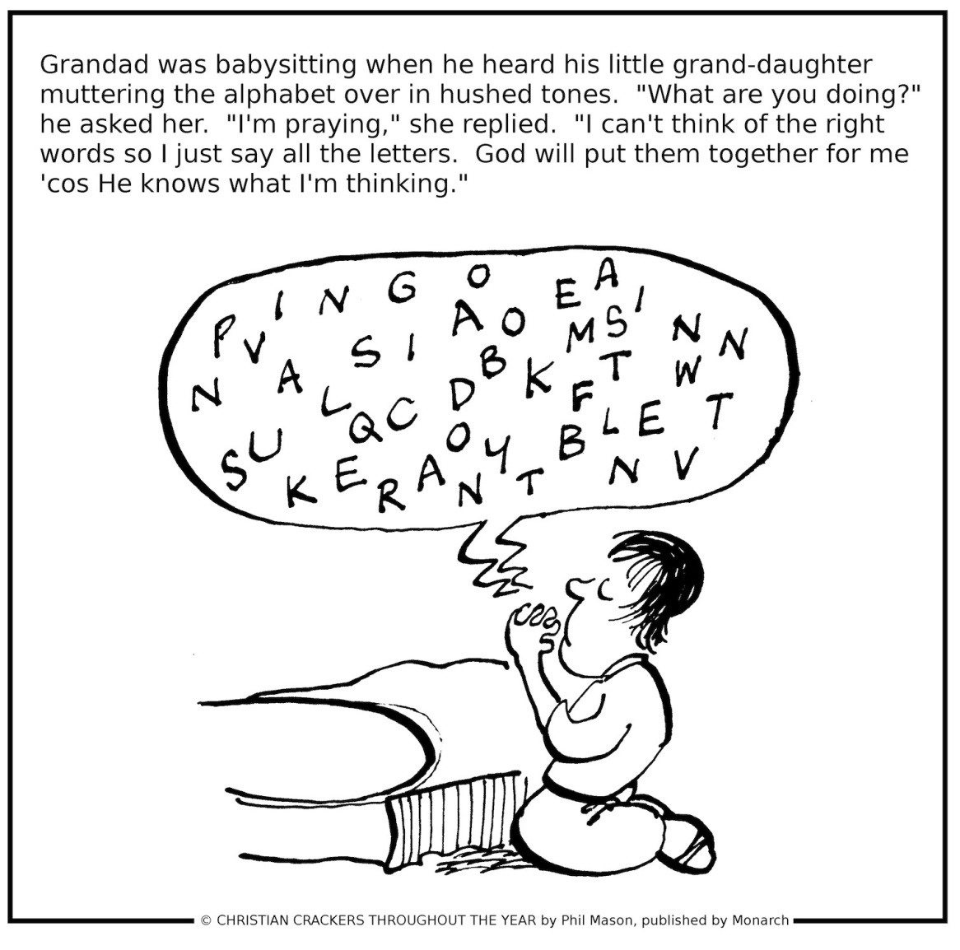

**All Saints, or All Hallows**, is the feast of all the redeemed, known and unknown, who are now in heaven. When the English Reformation took place, the number of saints in the calendar was drastically reduced, with the result that All Saints’ Day stood out with a prominence that it had never had before.

This feast day first began in the East, perhaps as early as the 5th century, as commemorating ‘the martyrs of the whole world’.  A Northern English 9th century calendar named All Hallows as a principal feast, and such it has remained.  Down the centuries devotional writers have seen in it the fulfilment of Pentecost and indeed of Christ’s redemptive sacrifice and resurrection.

The saints do not belong to any religious tradition, and their lives and witness to Christ can be appreciated by all Christians.  Richard Baxter, writing in the 17th century, wrote the following:

He wants not friends that hath thy love,  
And made converse and walk with thee,  
And with thy saints here and above,  
With whom for ever I must be…

As for my friends, they are not lost;  
The several vessels of thy fleet,  
Though parted now, by tempests tost,  
Shall safely in thy haven meet….

The heavenly hosts, world without end,  
Shall be my company above;  
And thou, my best and surest Friend,  
Who shall divide me from thy love?*

1,255 ancient English churches were dedicated to All Saints – a number only surpassed by those dedicated to the Virgin Mary.

*\*(Maurice Frost (ed.), Historical Companion to Hymns Ancient and Modern (London: Clowes, 1962), no. 274, verses 1,3,6.*

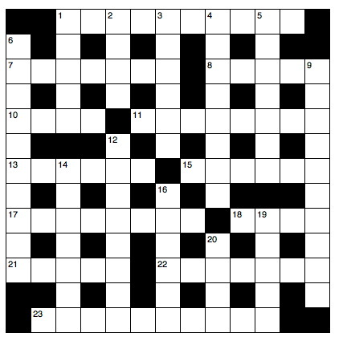**November Crossword**

**Across**

1 He was replaced as king of Judah by his uncle Mattaniah (2 Kings 24:17) (10)

7 ‘Let us fix our eyes on Jesus... who for the joy set before him — the cross’ (Hebrews 12:2) (7)

8 Relieved (5)

10 Impetuous (Acts 19:36) (4)

11 Surprised and alarmed (Luke 24:37) (8)

13 ‘It is — for a camel to go through the eye of a needle than for the rich to enter the kingdom of God’ (Mark 10:25) (6)

15 Directions for the conduct of a church service (6)

17 One of the acts of the sinful nature (Galatians 5:19) (8)

18 and 20 Down ‘She began to wet his — with her tears. Then she wiped them with her — ’ (Luke 7:38) (4,4)

21 ‘We will all be changed, in a flash, in the twinkling of an — , — the last trumpet’ (1 Corinthians 15:51–52) (3,2)

22 ‘But he replied, “Lord, I am — — go with you to prison and to death”’ (Luke 22:33) (5,2)

23 Third person of the Trinity (2 Corinthians 13:14) (4,6)

**Down**

1 He betrayed Jesus (Matthew 27:3) (5)

2 Paul’s assurance to the Philippian jailer: ‘Don’t — yourself! We are all here!’ (Acts 16:28) (4)

3 ‘Fear God and keep his commandments, for this — the whole — of man’ (Ecclesiastes 12:13) (2,4)

4 The sort of giver God loves (2 Corinthians 9:7) (8)

5 Sun rail (anag.) (7)

6 Naboth, the ill-fated vineyard owner, was one (1 Kings 21:1) (10)

9 Paul said of young widows, ‘When their sensual desires overcome their — to Christ, they want to marry’ (1 Timothy 5:11) (10)

12 This was how Joseph of Arimathea practised his discipleship ‘because he feared the Jews’ (John 19:38) (8)

14 Mop ruse (anag.) (7)

16 Foment (Philippians 1:17) (4,2)

19 Where Joseph and Mary escaped to with the baby Jesus (Matthew 2:14) (5)

20 See 18 Across

**OCTOBER ANSWERS**

**ACROSS:** 1. Bartholomew. 9, Evil one. 10, Adore. 11, Ran. 13, Oreb. 16, Zinc. 17, Entail. 18, Hung. 20, Lehi. 21, Joshua. 22, Pity. 23, Wide. 25, Age. 28, Alarm. 29, Partake. 30, Sennacherib.

**DOWN:** 2, Alive. 3, Took. 4, Over. 5, Onan. 6, Emotive. 7, Jehoshaphat. 8, Melchizedek. 12, A light. 14, Beg. 15, Strong. 19, Not have. 20, Law. 24, Iraqi. 25, Amen. 26, Epic. 27, Free.

