**The Parish of St. Mary,**

**Harrington with Salterbeck**

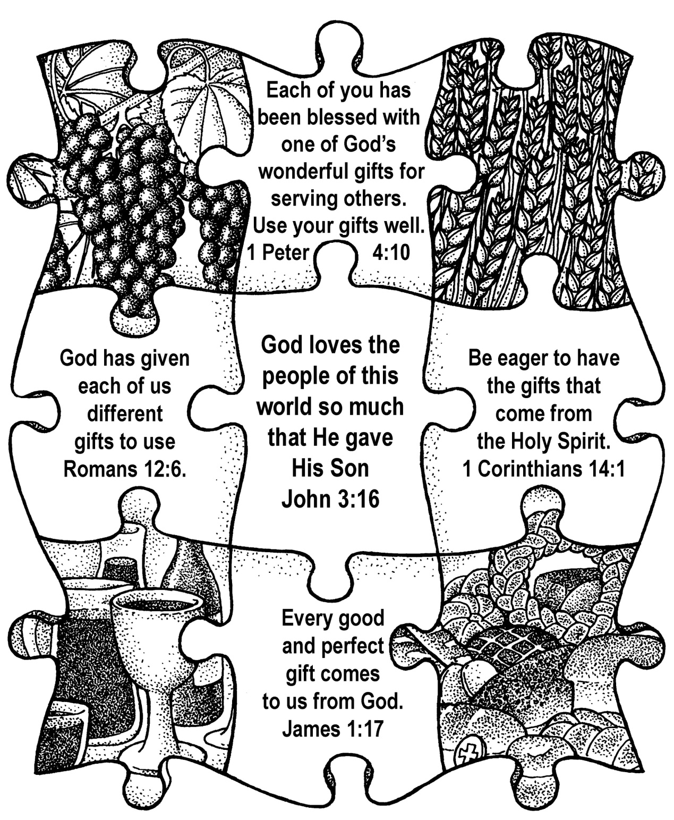

**September 2019**

**40p**

**St Mary’s Church**

Priest in Charge Rev Julia Powley 830215

Churchwardens Mr Ian Smith 831246

Mr Charles Murray 832507

PCC Vice-Chair Mrs Carol Callaway 833223

PCC Secretary Mrs Anne Falcon 0782 187 5509

PCC Treasurer Mrs Ann Brown 832384

Assistant Treasurer Mrs Carole Pattinson 830222

Our Website: New united benefice website! [www.stmarys-harrington-and-holyspirit-distington.co](http://www.stmarys-harrington-and-holyspirit-distington.co)

**Who to Contact**

**For Weddings, Baptisms, Funerals, House Communions, general enquiries or to arrange for somebody to be prayed for in church please contact Rev Julia Powley**

**Flowers in Church:** Marion Walker 834470

**Parish Magazine:** Andrew or Carol Callaway 833223

([a.callaway@talktalk.net](mailto:a.callaway@talktalk.net))

**Pew Sheet:** Ann Brown 832384

**Weekly Readings:** Susan Janulis 832653

[](http://images.google.com/imgres?imgurl=http://www.fotosearch.com/bthumb/ARP/ARP114/Phone_3.jpg&imgrefurl=http://www.fotosearch.com/illustration/dialing.html&usg=__D6wKw6FcmBvWkN8EqcouSrsUzfA=&h=145&w=170&sz=9&hl=en&start=12&tbnid=ewW80SF2DVHq8M:&tbnh=84&tbnw=99&prev=/images%3Fq%3Dtelephone%2Bclip%2Bart%26gbv%3D2%26hl%3Den)

Dear friends,

I hope that you have had a good summer, with plenty of sunshine in between the showers. September sees everything starting back again, from schools to uniformed organisations to toddlers. The challenge we have is whether this year will be the same as last or whether we can somehow make it better. I don’t mean politically (very much out of our hands) or even environmentally (though we can all do our bit there). I just mean in little ways in our relationships with each other.

In 1 Corinthians 13, the apostle Paul gives us a definition of love which include the words “Love is kind”. Our world is not always kind. Social media encourages folk to say just what they think, regardless of the effect it is going to have. Bullying is rife, in many different situations and age groups. But kindness can cost us nothing and make a huge difference.

Here is a little way in which we can do that, a way I discovered from social media! Next time we say “I’m sorry I’m late”, add on “thank you for waiting for me”. Next time we say “I’m sorry but I can’t make it tonight”, add on “thank you for inviting me”. Next time we say “I’m sorry for being emotional” add on “thank you for loving me”. I’m sure you can think of lots more examples.

What might the effect be? That we turn a critical culture, where there is always the need to apologise, into a culture where folk are accepted and grateful, and where there is an atmosphere of being appreciated and valued. That, my friends, is one very important aspect of Christian love.

With love,

Julia

**Where now?**

A teacher was finishing up a lesson on the joys of discovery and the importance of curiosity.

“Where would we be today,” she asked, “if no one had ever been curious?”

There was a pause, and then one child ventured: “In the garden of Eden?”

**M.U. News**

Our last meeting was the Summer Supper at the Galloping Horse where thirty two members and friends enjoyed a hot and cold buffet. We had lots of chat and puzzled together over an alphabet quiz. Our meetings, on the second Thursday of each month, begin again with a service in church followed by a get-together in the hall.

Dorothy Dodds our faithful indoor member sadly died in July. She had been in Mothers’ Union since 1971 and ‘was a great helper in so many ways.’

**Dates to Remember**

Monday 2nd September – Netherton Quiet Evening at 7.00pm

Thursday 12th September – M.U. Church Service then into the Hall for chat and M.U. information.

Kitchen ladies for September: Muriel Hill and Margaret Norman.

**Harvest field**

All around, confusion, all around, helplessness, people lost in the bad news of every day. Longing for purpose, searching for security and significance here in the white field of our generation.  
   
The harvest is still great, the workers are still few, but the Lord of the harvest is the same yesterday, today and forever, and this is his field. He planted, he will give growth if we will be his workforce and go out into the field – where he already is – to gather the harvest of his kingdom compassion.  
   
Lord of the harvest,  
In your grace, we pray,  
Send us.  
   
By Daphne Kitching

**Our Regular Activities**

|  |  |  |
| --- | --- | --- |
|  | **Events (many of these activities only run during term time. Please use contact number for details)** | **Contact (all codes 01946 unless otherwise stated** |
| **Sunday** | **Services in Church** at 8.00am and 10.30am (for further details of services, see page 12).  **Go 4 It** during 10.30am service on 4th Sunday of the month  **Study Group** at 7pm on alternate Sunday evenings | Rev Julia Powley 830215  Ann 832384  Susan 832653  Rev Julia Powley  830215 |
| **Monday** | **Pram Club** 10 – 11.30am, Church Hall  **Explorer Scouts** 7.15 – 9.15pm, Scout Hut, East Avenue | Marion Walker  834470  Andrew Hardy  832810 |
| **Tuesday** | **Cubs** 6 – 7.30pm, Scout Hut  **Crafty Mary’s** 3rd Tuesday 7.00pm | Fiona Woodward 832506  Rev Julia Powley  830215 |
| **Wednesday** | **Beavers** 5.30-6.30pm, Scout Hut  **Scouts** 7 – 9pm, Scout Hut | John Fleming 833630  Andrew Brown 832384 |
| **Thursday** | **Holy Communion** 9.30am, Church  **Pram Club** 10 – 11.30am, Church Hall  **Choir Practice** 7 – 8pm, Church  **Mothers Union** (2nd Thursday of month) 7.00pm, Church Hall  **Youth Group** 7.15pm – 8.30pm  (alternate Thursdays) | Rev Julia Powley 830215  Carole Pattinson  830222  Ann Hill 830072  Audrey Armstrong 830507  Andrew Callaway  833223 |
| **Saturday** | **Messy Church –** (3rd Saturday of month**)** 4pm to 6pm, Church Hall  **Soup on Saturday** - (2nd Saturday of month) 11.30am – 1pm, Hall  **Men’s Breakfast** – (last Saturday of the month) 9.30am. | Rev Julia Powley  830215  Rev Julia Powley  830215  Ron Hill  830072 |

**From the Registers – June/July 2019**

**HOLY BAPTISM**

We give thanks to God for the gift of new life. We remember in our prayers those little ones who have recently been baptised:

j033551216th June – Axell Penn born 9/1/19

16th June – Darren Fulton (adult)

16th June – Matthew Fulton (adult)

7th July – Ari Bish born 18/1/19

21st July – George Glithero born 29/8/13

21st July – Ruby Glithero born 26/7/18

28th July – Cole Murphy born 15/1/19

We pray for the parents and Godparents and their responsibility to bring up these children in the faith.

**HOLY MATRIMONY**

27th July    Kieron Sharkey and Rachel Quinton

We pray for God’s blessing on them as they begin their new lives together as husband and wife.

**THE DEPARTED**

We remember those whose earthly journey has come to an end:

Winnie Orr who died on 7th April 2019 aged 92

Jean Graham who died 27th May aged 90

Kathleen Mains who died 16th June aged 99

Thomas Moore who died 9th July aged 61

William Dawes who died 16th July aged 87

We commend all our departed loved ones to God’s eternal love and care. We remember all those who have lost loved ones and pray that God may strengthen, comfort and support them in their bereavement.

**Readings for September**

1st September     Trinity 11

Hebrews 13 vs 1 - 8 and 15 - 16    Luke 14 vs 1 and 7 - 14

8th September    Trinity 12

Philemon 1 - 21    Luke 14 vs 25 - 33

15th September    Trinity 13

Exodus 32 vs 7 - 14    Luke 15 vs 1 - 10

22nd September    Trinity 14

Amos 8 vs 4 - 7    Luke 16 vs 1 - 13

29th September    Michaelmas

Revelation 12 vs 7 - 12    John 1 vs 47 - 51

**Church Rota – September**

**Date** **Reader Prayers Sidespersons Chalice**

1st Sept Ian Charles Julie & Andrea Ian & Ann W

8th Sept Julie Family worship

15th Sept Susan Carol Muriel & Leah Chris & Carol

22nd Sept Kelly Ron Jacky & Kelly Mary Fr & Anne F

29th Sept James Tony Pauline & Marion Ann H & Muriel

[](https://www.google.co.uk/url?sa=i&rct=j&q=&esrc=s&source=images&cd=&cad=rja&uact=8&ved=0ahUKEwie7-e8sN7VAhUFUBQKHQR-B4gQjRwIBw&url=http%3A%2F%2Fwww.clipartpanda.com%2Fcategories%2Fcleaning-clip-art-for-free&psig=AFQjCNGtlcA0WyzFzwsd1qWZz6u_J3cO0w&ust=1503063080056030)**Church Cleaning – September**

31st Aug – Jackie Murray & Charles Murray

7th Sept – Andrea McTaggart

14th Sept – Eleanor Kerr & Ann Weir

21st Sept – Muriel Hill

28th Sept – Leah Brown & Sylvia Murphy

[](http://www.google.co.uk/url?sa=i&rct=j&q=&esrc=s&source=images&cd=&cad=rja&uact=8&docid=h3P92k1DFLkiUM&tbnid=ymBC3s0vFJBQAM:&ved=0CAUQjRw&url=http://www.colourbox.com/vector/cup-of-coffee-or-tea-vector-illustration-on-white-background-vector-2998457&ei=k-imU8P_F4akPdD4gcgI&bvm=bv.69411363,d.ZGU&psig=AFQjCNGylIaPwzYl-2NgvGruoCZykek-xQ&ust=1403533829002155)**Coffee Morning Rota – September**

1st Sept – Wrena & Andrea

8th Sept – Margaret & Audrey

15th Sept – Julie & Sue

22nd Sept – Marion & Muriel

29th Sept – Ann Brown & Susan

***If you can’t make any of these dates, please arrange a swap with someone.***

**Afternoon tea for Brain Tumour Charity**

**In memory of John Messenger**

I would like to thank all the family and friends who baked cakes, made sandwiches, gave the jam and cream, gave raffle prizes (and bought raffle tickets).

A total of £1537 was made. I requested the money goes to research into children’s tumours at Newcastle. John would have been delighted with this.

Many thanks for all the support you gave. I really appreciate it.

I would like to thank the church for the use of the hall.

Wrena

**Tuesday Morning Gang**

We currently have a group who meet on Tuesday mornings (9.30 to 11.30) to do odd jobs around the Church and Church Hall. If you have some spare time and would like to help please contact Ian Smith (831246)

**St Mary’s Youth Group**

**Starts again in October**

Meets every other Thursday from 7.15pm to 8.30pm. Meet up with your friends, learn more about our faith and have fun.

Held at 36 Seadown Drive, High Harrington. Call Andrew on 07963 755905 for more details.

**St Mary’s Church, Harrington – 250 Club**

 If you haven't already got your number but would like to be in the draw there are a few numbers left, please see Anne Falcon.

**July winners:**

1st number 66 Andrew & Carol Callaway

2nd number 64 Sandra & Paul McIndoe

3rd number 4 John Wilkins

Thank you to everyone who supports the 250 Club.

A reminder that the half year subs are due, if you want to join in have a chat to Anne Falcon.

**St Marys Horticultural Show 2019**

The 2019 Horticultural Show took place on Saturday 17th August. Numbers were up this year - there were 44 entrants (including 12 children) and approximately 300 exhibits. The Church Hall was filled to the brim with vegetables of all shapes and sizes, beautiful flowers (some a bit sad due to the heavy rain the day before), all sorts of crafts and home baking.

The winners of the sections were as follows:-

**Fruit and Veg Flowers**

1st – Gorgon Douglas 1st – Pamela Douglas

2nd – Jerry O’Connor Joint 2nd – Jean Slater/Clive & Gill

3rd – Doc Sewell

**Cookery Handicrafts**

1st – Karen Thompson 1st – Louise O’Connor

2nd – Marion Walker 2nd – Leah Brown

3rd – Louise O’Connor 3rd – Ruth Douglas

**Children (Age 0 - 7) Children (Age 8 – 11)**

1st – Isabella McKenna 1st – Emily Finn

2nd – Avieanna Davison 2nd – Neve Finn

3rd – Jude Bound 3rd – James McKenna

Highly Commended – Sam Johnston Highly Commended – Kobi Bound

and Luceaidye Davison

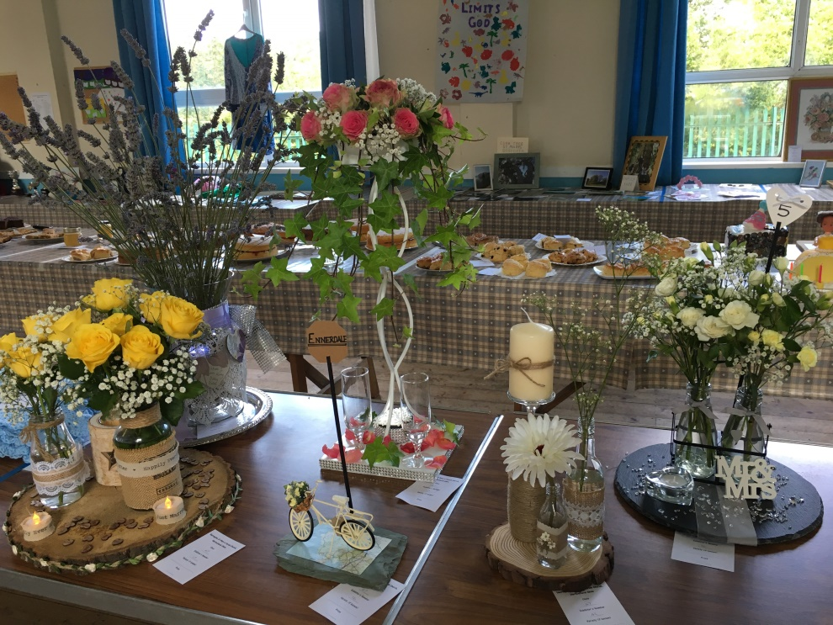

**Children (Age 12 -16)**

1st – Harry Woodward

2nd – Lily Isabella James

3rd – Ethan Bound

It was lovely to see so many people come to see the exhibits in the afternoon – there was plenty of tea/coffee, cake and crack to share – the show is becoming a lovely community event. We have one small problem though – we need that extension on the Church Hall!

Thank you to the judges – George, Doreen and Julia – it gets more difficult each year! The show is open to everyone to enter – we are all novices who just enjoy making, baking, and/or growing. Next year why don’t you come along and enter something – you never know what you can do until you try.

Thanks also to those who provided raffle prizes and helped out in the kitchen. A total of £206.34 was made on the day which will be split between Church and the Bishop’s Harvest Appeal.

Well done to all the enthusiastic exhibitors – you created a fantastic show!

Same place, same time next year?

**Fund raising event for the church windows.**

Entertainment from the Ewanrigg Community Choir with a special guest.

This is on Friday 27th September from 7.00 to 9.00pm in the St Mary’s Church Hall.

There will be a raffle too.

Tickets are £5 on the door.

For more information see Sandra McIndoe

**Collections for June 2019**

3rd - £165.00

10th - £175.20

17th - £155.70

23rd - £145.20

30th - £183.50

**July Collections -**

7th - £198.00

14th - £134.50

21st - £154.50

28th - £139.00

Our thanks to those who continue to support us with their giving.



Did you know that if you are a taxpayer, for every £1 donation you make to the Church we can claim 25p tax back from H M Revenue & Customs (at no extra cost to you). If you have not already signed a Gift Aid declaration please see Ann Brown for a form. **Thank You**

**Soup on Saturday**

**[](http://www.google.co.uk/url?sa=i&rct=j&q=&esrc=s&frm=1&source=images&cd=&cad=rja&docid=5uivsYii7L8sRM&tbnid=i1DJjFjs1ejO2M:&ved=0CAUQjRw&url=http://griggstownfarm.com/food-of-the-week/food-of-the-week-soup-4/&ei=ZDQGU8usAsfL0AX88oCADQ&bvm=bv.61725948,d.ZG4&psig=AFQjCNGal-I_dPHLRYQjePg0hdXLaTkWRA&ust=1393001927748727)At St Mary’s Parish Church Hall, Harrington**

[](http://www.google.co.uk/url?sa=i&rct=j&q=&esrc=s&frm=1&source=images&cd=&cad=rja&docid=5uivsYii7L8sRM&tbnid=i1DJjFjs1ejO2M:&ved=0CAUQjRw&url=http://griggstownfarm.com/food-of-the-week/food-of-the-week-soup-4/&ei=ZDQGU8usAsfL0AX88oCADQ&bvm=bv.61725948,d.ZG4&psig=AFQjCNGal-I_dPHLRYQjePg0hdXLaTkWRA&ust=1393001927748727)**Good Food and Good Company**

**Saturday 14th September 11.30am – 1pm**

**ALL WELCOME**

Come and join us for a bowl of delicious homemade soup, a bread roll and a cup of tea/coffee all for just £2.00 – we do hope you can join us and we guarantee a warm welcome to all.

**MC900354041[1]Pram Club**

Pram Club meets in the Church Hall on Mondays and Thursdays from 10am to 11.30am during term time. Parents, Grandparents and carers are all welcome – have a chat and a cuppa and watch the children play.

**WANTED**



Dolls and dolls pushchairs for use at Pram Club.

If you have one going spare can you pass it on to Carole Pattinson.

Thank you

BOOK CLUB

[](https://www.google.co.uk/url?sa=i&rct=j&q=&esrc=s&source=images&cd=&cad=rja&uact=8&ved=0ahUKEwi52M6Kvd7VAhVGPhQKHe26BH0QjRwIBw&url=http%3A%2F%2Fwww.erringdenbenefice.org.uk%2Fgroups7%2Fbook-club%2F&psig=AFQjCNECdrjs9QWWZAoZ12xUqHFAuTMqnA&ust=1503066462336767)Do you enjoy reading and like to have a chat about the books you read? If you do then our Book Club is just for you. We meet in the Church Hall every other month after Soup on Saturday. The next meeting is on Saturday 14th September 2019 at 1.00pm and the book we are discussing is ‘The Visitors’ by Simon Sylvester.

[](http://www.google.co.uk/url?sa=i&rct=j&q=&esrc=s&frm=1&source=images&cd=&cad=rja&docid=pjMAwkgIExD86M&tbnid=xbgQRICeGCRMRM:&ved=0CAUQjRw&url=http://www.clker.com/clipart-blue-hand-print.html&ei=BBwVUvLjOeyd0wXO2ID4Dw&bvm=bv.50952593,d.d2k&psig=AFQjCNEQoWVDex0p9hA6AhD-yQvS_XufKQ&ust=1377200804456924)**Go 4 It**

[](http://www.google.co.uk/url?sa=i&rct=j&q=&esrc=s&frm=1&source=images&cd=&cad=rja&docid=pjMAwkgIExD86M&tbnid=xbgQRICeGCRMRM:&ved=0CAUQjRw&url=http://www.clker.com/clipart-blue-hand-print.html&ei=BBwVUvLjOeyd0wXO2ID4Dw&bvm=bv.50952593,d.d2k&psig=AFQjCNEQoWVDex0p9hA6AhD-yQvS_XufKQ&ust=1377200804456924)Go 4 It is usually held on the fourth Sunday of the month at 10.30am in the Church Hall and is for children of all ages - parents are more than welcome to join us or you can join the service in Church if you wish. Go 4 It includes crafts, songs, stories, games and prayers. We then join the service in Church at approximately 11.15am. All welcome – come along and join us!

**Important Dates – September 2019**

Sunday 1st Holy Communion 8.00am

Holy Communion 10.30am

Thursday 5th Holy Communion 9.30am

Choir practice 7.00pm

Sunday 8th Holy Communion 8.00am

Family service in the hall 10.30am

Healing service 6.00pm

Thursday 12th Holy Communion 9.30am

Mothers Union 7.00pm

Friday 13th Film Club 7.00pm

Saturday 14th  **Soup on Saturday 11.30am - 1.00pm**

Coffee morning, Distington in the Old Chapel at 10am

Sunday 15th Holy Communion 8.00am

Holy Communion 10.30am

Study group 7.00pm

Tuesday 17th Crafty Mary’s 7.00pm

Thursday 19th Holy Communion 9.30am

Choir practice 7.00pm

Saturday 21st **Messy Mary’s 4.00 – 6.00pm**

Scout music night – see Ann Brown

Sunday 22nd Holy Communion 8.00am

Holy Communion 10.30am

Study group 7.00pm

Thursday 27th Holy Communion 9.30am

Choir practice 7.00pm

**Fund raising concert, church hall 7.00 – 9.00pm**

**Important Dates – September 2019 cont.**

Saturday 28th Men’s breakfast 9.30am

Sunday 29th Holy Communion 8.00am

Holy Communion & **Go for it** 10.30am

Study group 7.00pm

***Parish Magazine***

Thank you to all distributors who deliver the parish magazine all through the year, in all weathers - your help is much appreciated.

We have now revised all the distribution lists and it would be good if we could keep these lists up to date. To enable us to do this, if you add or remove anyone from your list please let Ann Brown know, thank you.

Also, if you are reading this magazine and don't receive a monthly copy (but would like to) or if you know someone who would like to receive the magazine each month, please contact Ann Brown (01946 832384) and we will add you to the relevant distribution list. There are 10 issues each year and the cost is £4.00 per year.[](http://www.google.co.uk/url?sa=i&rct=j&q=&esrc=s&frm=1&source=images&cd=&cad=rja&docid=8Cv8WzIS2mPlAM&tbnid=Lsq49XEepBFCMM:&ved=0CAUQjRw&url=http://www.clker.com/clipart-hand-print-pink.html&ei=cicVUsOUC7Ok0AXN4IH4Bg&bvm=bv.50952593,d.d2k&psig=AFQjCNG3mo_rKvDYkKBcR43kh5tAjYB7Pw&ust=1377204165285914)

**Men’s breakfast**

**If you like good company, good food and a good chat then men’s breakfast is right up your street. We meet at the Galloping Horse usually on the last Saturday of the month at 9.30am. If you want to know more give Ron Hill a call (830072) or pop along to our next breakfast on Saturday 28th September.**

**July 5p collection**

You have collected £38.95 this month.

Thanks Carol.

**MC900216560[1]Home Communion**

If you know of anyone who would like home communion please contact Julia (01946 830215)

**Welcome Packs**

[](https://www.google.co.uk/url?sa=i&rct=j&q=&esrc=s&source=images&cd=&cad=rja&uact=8&ved=0ahUKEwjarrzz8t7VAhVPsBQKHTADCOEQjRwIBw&url=https%3A%2F%2Fwww.clipartsgram.com%2Fwelcome-visitors-clipart-34494&psig=AFQjCNFb3CruxIIfNDj2-bcMJiFSteF5IQ&ust=1503080812828229)We have put together welcome packs for families moving into the new estates in Harrington. They contain general information about the area (schools, doctors, libraries, shops, local clubs etc), bus timetables, bin collection dates etc as well as information about St Marys and what we do and (most importantly) chocolate. If you notice someone new moving into a house near you, please ask for a pack to deliver to them and say hello!

**October Magazine**

We would be pleased to receive any articles, news or items of interest for inclusion in the Parish magazine. If anyone has anything to be included in the May magazine, please give it to Julia or Andrew or Carol Callaway before 19th September 2019.

[](https://www.google.co.uk/url?sa=i&rct=j&q=&esrc=s&source=images&cd=&ved=0ahUKEwilguzg897VAhUGzRQKHXQuDcMQjRwIBw&url=http%3A%2F%2Fwww.educationabroadasia.com%2Fphuket-film-club%2F&psig=AFQjCNFPZmYyFXnPMAEKt2dySpwjB7KTzA&ust=1503081015770757)[](https://www.google.co.uk/url?sa=i&rct=j&q=&esrc=s&source=images&cd=&cad=rja&uact=8&ved=0ahUKEwj33uyl897VAhUE7BQKHaIuBrQQjRwIBw&url=http%3A%2F%2Fwww.sjsb.co.uk%2Fextra-curricular%2Ffilm-club%2F&psig=AFQjCNFPZmYyFXnPMAEKt2dySpwjB7KTzA&ust=1503081015770757) **Film Club**

Next Film Club Evening is Friday 13th September at 7pm. There is no charge to either join the club or view films but a suggested donation of £2 for each film you watch would be great. This is just to cover our costs and will include tea, coffee or juice.  If you would like to bring your own wine we will provide glasses. Film club is open to anyone over the age of 18.

**Church Hall**

The Church Hall is available for private hire. Please contact Sheila Richardson (07710 996695) for further details and bookings

**Crafty Mary’s**

[](http://www.google.co.uk/url?sa=i&rct=j&q=&esrc=s&source=images&cd=&cad=rja&uact=8&ved=0ahUKEwiikYXUuZ3MAhWEnRoKHXWYA_MQjRwIBw&url=http://dicdevelopmenttrust.com/craft-club/&bvm=bv.119745492,d.d2s&psig=AFQjCNEjhHhw0k_zaq8p3_zUSq2_m7dSsw&ust=1461249397742568)We have a craft club at St Mary’s on the third Tuesday of each month in the Church Hall. Please don’t feel that you have to be good at something – we just want to get together with friends for a cuppa and enjoy making/doing or whatever – some of us have now started making things for charities. If you are interested, please come and join us on Tuesday 17th September and bring your friends – all are very welcome.

**Open Church**

At the beginning of September church is closed owing to family commitments. We open again on Tuesday 17th September from 10.30am to 2.30pm.

We should then be open every week.

Second hand book stall will be opened during this time..

Carol Callaway

01946 833223

**Toothy grin**  
Whilst working for an organisation that delivers lunches to the elderly, I used to take my four-year-old daughter on my afternoon rounds. She was unfailingly intrigued by the various appliances of old age, particularly the canes, walkers and wheelchairs.

One day I found her staring at a pair of false teeth soaking in a glass. As I braced myself for the inevitable barrage of questions, she merely whispered, ‘The tooth fairy will never believe this!’

**September Crossword**

**Across**

1 ‘A little later someone else saw Peter and said, “You — are one of them”’ (Luke 22:58) (4)

3 Giving (1 Peter 2:5) (8)

9 They came to Jerusalem seeking an infant king (Matthew 2:7) (3,4)

10 ‘An athlete... does not receive the victor’s crown unless he competes according to the — ’ (2 Timothy 2:5) (5)

11 Pacifist, temperance advocate, open-air preacher, leading 20th- century Methodist, Donald — (5)

12 ‘Come quickly to — — , O Lord my Saviour’ (Psalm 38:22) (4,2)

14 ‘The God of Abraham, — — — , the God of our fathers, has glorified his servant Jesus’ (Acts 3:13) (5,3,5)

17 Sear by intense heat (Revelation 16:8) (6)

19 ‘It is better to take refuge in the Lord than to trust — — ’ (Psalm 118:8) (2,3)

22 Goods (Nehemiah 13:15) (5)

23 i.e. train (anag.) (7)

24 Surrounding area (Luke 24:50) (8)

25 ‘Righteousness will be his — and faithfulness the sash round his waist’ (Isaiah 11:5) (4)

**Down**

1 Elegant and creative (Exodus 31:4) (8)

2 ‘Listen, I tell you a mystery: We will not all — , but we will all be changed’ (1 Corinthians 15:51) (5)

4 ‘I... delight to see how orderly you are and how firm your — — — is’ (Colossians 2:5) (5,2,6)

5 Enlist (2 Samuel 24:2) (5)

6 Of the Muslim faith (7)

7 Sharp intake of breath (Job 11:20) (4)

8 Woven cloth (Ezekiel 16:13) (6)

13 Plentiful (Romans 5:17) (8)

15 CIA char (anag.) (7)

16 Paul and Silas stopped him committing suicide after an earthquake in Philippi (Acts 16:27–28) (6)

18 One of the ingredients in the making of incense for the Lord (Exodus 30:34) (5)

20 Episcopal headwear (5)

21 Inhabitant of, say, Russia, Ukraine, Poland, Slovakia or Bulgaria (4)

**July/August ANSWERS**

**ACROSS:** 1, Riches. 4, Abner’s. 7, Soul. 8, Damascus. 9, Statutes. 13, Add. 16, Craftsmanship. 17, Old. 19, Redeemer. 24, Walls are. 25, Wise. 26, Target. 27, Thieve.

**DOWN:** 1, Rest. 2, Courtyard. 3, Sadhu. 4, Arm he. 5, Nose. 6, Round. 10, Tutor. 11, Timid. 12, Sense. 13, Ashbelite. 14, Dips. 15, Echo. 18, Lhasa. 20, Exact. 21, Erect. 22, Flog. 23, Mede.

