|  |  |
| --- | --- |
| **E. LAMB AND SON**  ***Est. 1944***  ***Spares / Appliances***  ***Solid Fuels Bottled Gas***  **Tel: 01946 830353** | **Lynda Elliot**  **Hairdresser**  **C:\Users\Barbara Lamb\AppData\Local\Microsoft\Windows\Temporary Internet Files\Content.IE5\06JCVCET\MC900324786[2].wmf**  **Tel: 01946 830504**  **Mobile: 07798 648233** |
| **YEOWART, GILL AND RUDD**  **Chapel of Rest, Low Monkwray**  **Prop: John, David & Margaret Yeowart**  The Family funeral service  People committed to a dignified service at the lowest cost  GOLDEN CHARTER  Pre-paid Funeral Plan  Details available on request  **Tel: 01946 693819/692939**  **(24 hours)**  **Beware of recommendations that could be costly!!** | **TOM EDGAR**  **Funeral Services**  Caxton House, 13 Brow Top  Workington, CA14 2DP  Private Chapels of Rest  Tel: 01900 603388  Email: tom.edgar1@btconnect.com  **24 HOUR SERVICE** |



**Church of the Holy Spirit****Parish Magazine**

**What’s on in the village?**

**All of the following activities take place in the Community Centre. For further details please telephone 01946 834297**

**Baby & Toddler Group:** Every Wednesday (Term Time) 10am

**Lunch Club:** 2nd Friday of the month at 12 noon

**Family and Local History:** Every third Tuesday from 7 - 9 pm

**Art Class**: Most Tuesdays from 6.15 – 8.15 pm

**Craft Club**: Every Tuesday from 1 - 3 pm

**Evergreens**: Thursdays from 1 – 3 pm

**Reading Group:** Every second Monday from 2 pm (in the Library)

**Knit and Knatter:** Every Friday from 1 -3 pm

**“Old Folks” Bingo**: Every Monday at 8 pm

**Fit 4 Life**: Every Tuesday from 11 – 12.15 am

**Parish Council** meets every second Monday at 7 pm in the Club for Young People

**Mothers Union**: every first Wednesday in the month at 7 pm in the Community Centre

**Distington Club for Young People**: if you require further information please contact Christine on 832882

-o-o-o-o-o-o-o-o-o-o-o-o-o-o-o-o-o-o-o-o-o-o-o-o-o-o-o-o-o-o-o-



|  |  |
| --- | --- |
|  | **John Sandelands Funeral Directors Ltd**  **Tel: 01900 602753**  **Rest Chapels at;**  Main Road, Seaton  South William St, Workington  Bridge Street, Cockermouth |

**Wall & Tree Cockermouth**

* **Hedge & Tree maintenance & removals**
* **Grass Cutting, garden tidying & clearances**
* **Small landscaping projects**
* **Fence installation, painting & repair**
* **Firewood & chainsaw work**
* **General garden D.I.Y.**

**We can work within your budget**

**Contact Dale for a no obligation quotation**

**Tel. 01900 828947 mob 07907 225 316**

**E-mail moose.moore@live.co.uk**

**THE CHURCH OF THE HOLY SPIRIT, DISTINGTON**

**Rector: Revd. Julia Powley, The Rectory, Rectory Close, Harrington, Workington, CA14 5PN Tel: 01946 830215**

**Churchwardens Marlene Pettit**

**Lay Chair Doreen Belford**

**Secretary Barbara Lamb**

**Treasurer Doreen Belford**

**Electoral Roll**

**Officer Barbara Lamb**

**PCC Members as above plus**

**Helen Finn, Julia Hoggarth, Nicola Stephenson, Pat Nelson, Rhoda Robinson, Ray Bailey & Rosalind Brough**

**Sides Persons Ann Blakemore, Joan, Milligan, Rosalind Brough, Sandra Parry, Brenda Bailey & Pat Nelson**

|  |  |  |
| --- | --- | --- |
| **For any information needed about Baptisms, Weddings or Funerals please contact**  **Revd. Julia Powley Tel: 01946 830215** | | |
| **Triple TTT Ltd**  **The Old Job Specialists doing the Jobs you hate**  ***Window cleaning – power spraying***  ***Guttering – painting – brick laying***  **Van Hire with Driver, fully insured – mini removals**  ***Grasscutting – tree pruning – hedge cutting***  ***Commercial and household cleaning***  **COMPETITIVE QUOTES**  **01900 810008**  **07934 770328** | **Advertise Here?**  **Find out more about our great yearly rates**  **for more information, contact**  **Barbara Lamb**  **07425 792 995** |
| **Brockbank Curwen Cain and Hall**  Solicitors and Notaries  44 Duke Street  Whitehaven CA28 7NR  Tel: 01946 692195  Also at Cockermouth, Maryport, Workington and Keswick   * **Home Information Packs** * **Residential and Commercial Conveyancing** * **Wills and Probate** * **Court of Protection** * **Personal Injury** * **Matrimonial** * **Crime** * **Employment**   www.brockbanks.co.uk | **DISTINGTON**  **COMMUNITY CENTRE**  **The Centre runs training events and other community activities including public meetings. The Mabel Knowles room is a committee room available for small meetings – capacity 25. The Main hall is available for events, activities, and private parties etc. – capacity 100.**  **Full new kitchen available**  **For further details**  **tel: 01946 834297** |

**Flowers**

Do you have loved ones who you like to remember with flowers?

Did you know you can display flowers in memory of your loved ones in church?

These can be displayed on the altar or throughout the church.

**For more information please speak to**

**Nicola Stephenson on 07933551524.**

**Church Memorial Book**

If anyone would like to have their loved one’s details added to our memorial book in Church, please speak with Julia Powley.

There will be a small charge of £5 per name

Dear everyone,

And so the year moves onwards, the nights drawn in and the adverts starting to tell us that we need to go crazy and spend all our money on Christmas. But before we get to that point, we have the season of remembering, the season when memorial service and remembrance service dominate the first half of the month. By the time you read this, we might even be out of the EU. It would be poignant if that happened at this time of year, when we remember the carnage caused when Europe was at loggerheads with itself.

On November 22nd in Keswick, there is a lecture at Keswick Methodist Church by a theologian called Anna Rowlands. The lecture is entitled: A Fractured Nation – Brexit and the Christian Vision of the Common Good. It is open to everyone though you need to book tickets. It is acknowledging that the Brexit debate has divided the nation and that, after the politics, we need those divisions to be healed if we are going to flourish together.

In my role, I see division at all levels, from within individual families to within communities and within the national church. Jesus told us that as church we are called to be one, but we have failed miserably on that front. Thankfully, the pressures facing the church today are drawing us back together, at least on a local level.

As we remember the cost of division for our nation and for individual families who lost their loved ones to war, I pray that we will find ways to heal the divisions of today, that families, communities and our nation might know reconciliation and peace. Because war comes at too high a cost, even within a family.

With love,

Julia

The Church of the Holy Spirit warmly invites you to our…

**Baby and Toddler Group**

Distington Community Centre

Every Wednesday in school term time

10am start

Babies and toddlers with their parents/carers are welcome

£1 per family

For more information please contact Julia Hoggarth on 07747581390

**Lunch Club**

Monthly on the 2nd Friday 12noon - 2pm

Next one is;

**8th November 2019**

Distington Community Centre

Beautiful food served at fantastic prices

One, two or three courses with tea & coffee

**Your Church Needs You!**

* To go on the rota to read a lesson
* To go on the list to lead prayers
* To go on the cleaning rota
* To go the rota to print the magazine
* To be a sidesperson
* To be a member of the PCC

If you can help, please speak with

Julia Powley

**From the Parish Registers**

**Marriages**

We wish them a long and happy life together

**Carl Pickering and Leanne Johnson**

7th September 2019

**Website**

We have a new website for the United Benefice which covers the activities of both St Mary’s Harrington and The Holy Spirit Distington. The website is still in development, so we are looking for comments and ideas to include. Have a look and tell either James Mossop or Andrew Callaway (me!) what you think. The web address is [www.stmarys-harrington-and-holyspirit-distington.co](http://www.stmarys-harrington-and-holyspirit-distington.co) If you want to email your thoughts my email address is [a.callaway@talktalk.net](mailto:a.callaway@talktalk.net)

Thanks Andrew

**CHURCH CLEANING ROTA**

**NOVEMBER 2019**

3rd Julia & Helen

10th Lynda & Edwina

17th Sandra & Trudy

24th Katrina & Carl

December 1st Julia & Helen

If you are unable to make the week you are due to clean, please let Sandra know on 01946 830046.



**100 CLUB  
It’s that time again – time to enter the 100 Club draw.**

**Final Reminder for Anyone Wishing to Enter**

**Were you a winner last year?** **No**, well it **MUST** be your turn this time. Remember you must be in it to win.

The cost of a number is £12.00 for the year. If we have 60 people entering the prize money would be £30.00 and the remaining £30.00 would go to Church funds.

If you are interested, please complete the slip below and return it to any member of the PCC along with your £12.

- - - - - - - - - - - - - - - - - - - - - - - - - - - - - - - - - - - - - - - - - -

Name ………………………………………………………..

Address ………………………………………………………

……………………………………………………………………

Tel. No. …………………………………………………….

**Church of the Holy Spirit**

**Future Dates for your Diary!**

**Memorial Service**

3rd November 2019 3pm in Church

**Chocolate Bingo**

1st November 2019 in Community Centre

**Christmas Fair**

24th November 2019 12noon in Community Centre

**Christingle**

10th December 2019 6pm in Church

**Distington School Carol Service**

20th December 2019 9.15am in Church

**Carols by Candlelight**

22nd December 2019 4pm in Church

**Crib Service**

24th December 2019 5.30pm in Church

**Midnight Mass**

24th December 2019 11.30pm in Church

**Church of the Holy Spirit**

**CHOCOLATE**



**Friday 1st November**

**7pm**

**DISTINGTON COMMUNITY CENTRE**

**Jacket Potatoes and Cakes**

**Tickets £6 (children £3)**

**ALL WELCOME**

**Church of the Holy Spirit**

**CHRISTMAS FAIR**

**Sunday 24th November**

**12 noon – 2 pm**

**DISTINGTON COMMUNITY CENTRE**

**Tombola * Raffle * Cake stall**

**Craft stall**

**Turkey rolls *** Tea *** Coffee**

**EVERYONE WELCOME**





To “West Cumberland Engineering Ltd” at Lillyhall, for the help they have given us with the work carried out on the flag pole at the War Memorial.

They have help us to release a seized up mechanism which allowed the pole to be dropped. This was needed as the pole needed to be re roped.

They have carried this work out as a Community project, therefore it has cost us nothing!

Quite honestly, we can’t thank them enough!!

**Church of the Holy Spirit**

**Remembrance Sunday**

The Remembrance Day service and parade will be on Sunday 10th November 2019.

This is just a reminder to everyone in the village that the service starts at 09.45hrs and then on to the War Memorial for 11.00hrs.

There will be pie and peas, and hot drinks in the community centre following the parade for anyone who would like to come.

We would also like to say that if anyone would like to come but can't due to mobility problems, we could arrange transport for them. We don't want anyone to feel excluded because they can't manage. Please contact a member of the Parish Council.



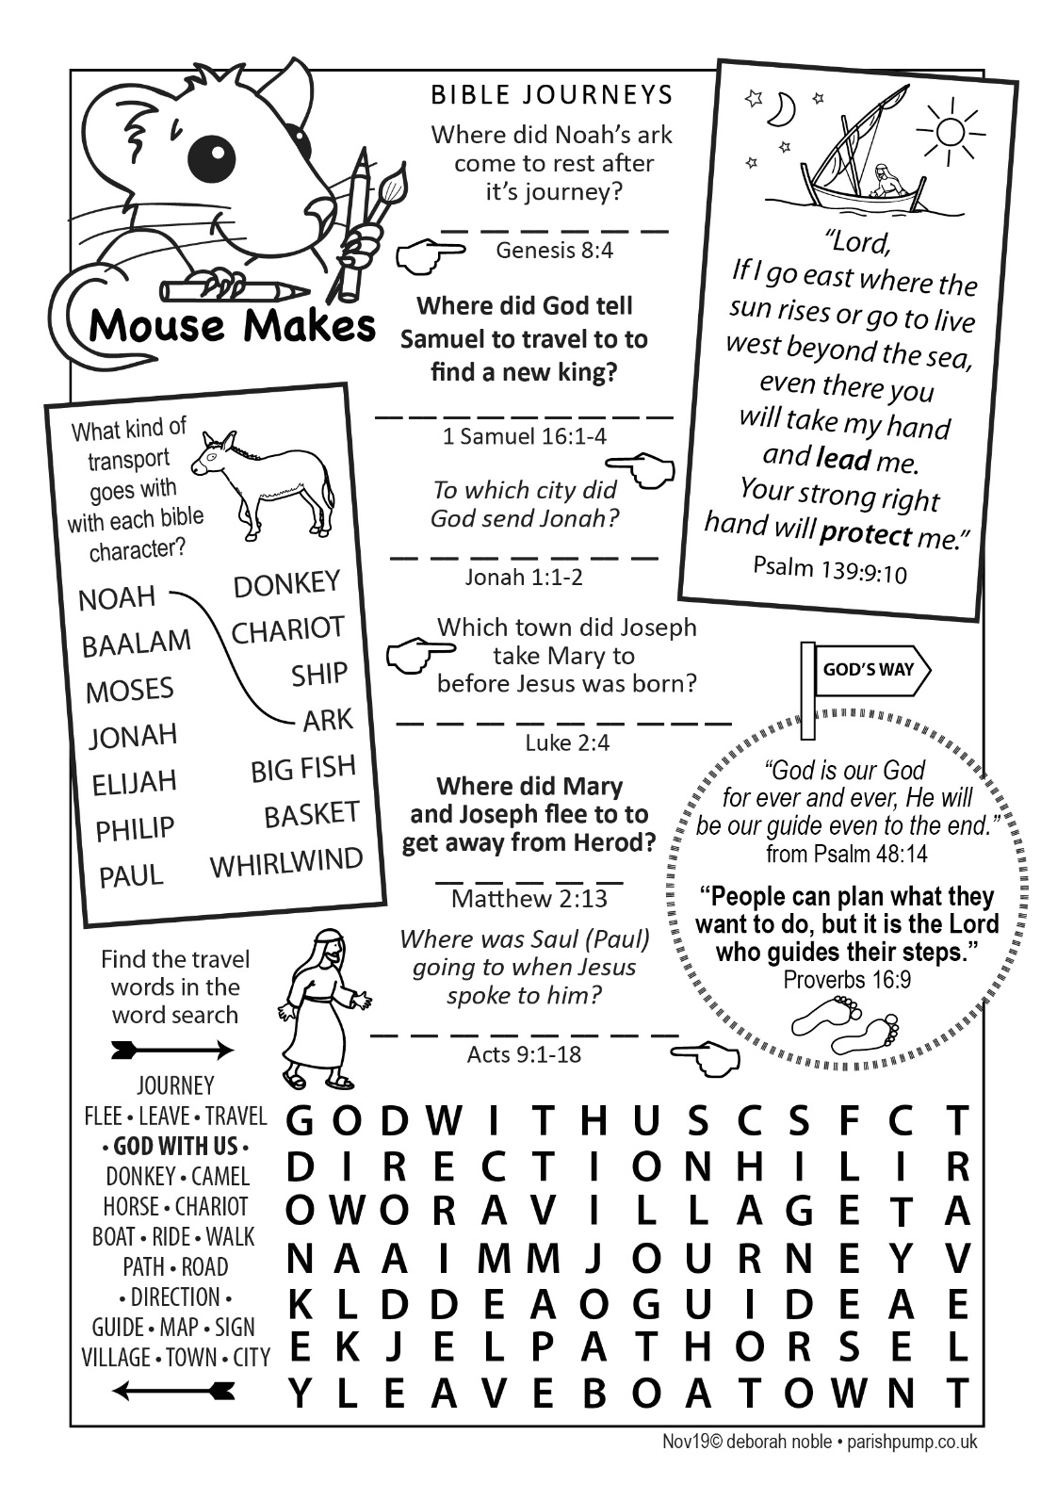

**PEACE**

On the eleventh day of the eleventh month  
The guns had ceased and peace had come,  
Another war with so much loss  
As brave men fought and victories won.

We honour those who gave their lives  
And took up arms against the foe,  
Not knowing if they would return  
But faithful to the call to go.

Battles rage throughout the earth,  
It seems that wars will never cease  
Until the day that Christ returns –  
And only then will there be peace.

The Prince of Peace, Emmanuel  
Will come to end this world of strife  
And as He brings His kingdom in  
He’ll usher in eternal life.



**Fall of the Berlin Wall – 30 years ago**

The Berlin Wall fell 30 years ago this month, on 9th November 1989. East Germany reopened its border with West Germany, allowing its citizens to pass freely through the checkpoints. Workers began demolishing the 28-year-old wall the next day.

Earlier that year serious unrest in Eastern Bloc countries such as Poland and Hungary had put pressure on the East German government, which had also been dealing with demands from its own citizens, led by a determined ‘swords into ploughshares’ church movement for peace.

The wall was relatively low but heavily fortified, separating the democratic Western countries and the Communist countries of Eastern Europe throughout the Cold War. East German border guards were authorised to shoot anyone attempting to escape into West Berlin. More than 100 people died in that way, but hundreds more were killed trying to cross at other border points.

German reunification took place formally on 3rd October 1990.

One of the casualties of the building of the wall in 1961 was the Church of Reconciliation, which was separated from most of its parishioners and eventually demolished to make it easier for guards to shoot potential escapees. The same site now houses the clay-built Chapel of Reconciliation, consecrated in November 2000.

**Coffee, Cake and Craic**

Distington Methodist Chapel

Most Wednesdays

from 10.15am

All Welcome

**Memorial Service**

**3rd November 2019**

**3pm**

We will be holding our annual memorial service, as we give thanks for those whom we love but who have died.

All are welcome to the service.

Remember your loved ones with a special message on a tag which will be displayed on our Church Christmas Tree.

Tags are available for £5 each

Speak to Pat Nelson, Julia Powley, or Nicola Stephenson or they are available in Church

|  |  |
| --- | --- |
| **NOVEMBER** | |
| **Date** | **Event** |
| Fri 01/11/2019 | 7pm - Chocolate Bingo in Community Centre |
| Sun 03/11/2019 | 3pm - Memorial Service for those we love but no longer see No morning service |
| Wed 06/11/2019 | 9.30am - Holy Communion 10am - Toddler Group in Community Centre |
| Sun 10/11/2019 | 9.45am - Remembrance Service |
| Wed 13/11/2019 | 9.30am - Holy Communion 10am - Toddler Group in Community Centre |
| Sat 16/11/2019 | 4pm - Messy Marys in Harrington Church Hall |
| Sun 17/11/2019 | 3pm - Church in the Afternoon |
| Wed 20/11/2019 | 9.30am - Holy Communion 10am - Toddler Group in Community Centre |
| Sun 24/11/2019 | 9.15am - Holy Communion 12noon - Christmas Fair in Community Centre |
| Wed 27/11/2019 | 9.30am - Holy Communion 10am - Toddler Group in Community Centre |

|  |  |  |  |  |
| --- | --- | --- | --- | --- |
|  | **READINGS** | **READER** | **SIDESPERSON** | **FLOWERS** |
| **4th November (Memorial Service)** | **Psalm 42 John 11 vs 17 - 27** | **Parishioners** | **Rosalind Brough Pat Nelson** | **Rhoda Robinson** |
|
| **11th November  (Remembrance Sunday)** | **Micah 4 vs 1 - 5 John 15 vs 9 - 17** | **Parish Council** | **Barbara Lamb Brenda Bailey** | **Lynda Elliott** |
|
| **18th November** | **Malachi 4 vs 1 - 2a Luke 21 vs 5 - 19** | **Sandra Rector** | **Rosalind Brough Pat Nelson** | **Margaret Ogilvie** |
|
| **25th November** | **Colossians 1 vs 11 - 20 Luke 23 vs 33 - 43** | **Julia H Rector** | **Barbara Lamb Brenda Bailey** | **Margaret Ogilvie** |
|
| **2nd December** |  | **Childrens Church** | **Sandra Parry Ann Blakemore** | **Nicola Stephenson** |
|

**Thank You**

A big thank you to the team of people involved in making our village look beautiful with flowers, and keeping them watered throughout the summer months and also winter too.

A special mention to Bob and Jim Bennett for all their hard work, help and support with flowers in the village and foliage for church.