|  |  |
| --- | --- |
| **E. LAMB AND SON**  ***Est. 1944***  ***Spares / Appliances***  ***Solid Fuels Bottled Gas***  **Tel: 01946 830353** | **Lynda Elliot**  **Hairdresser**  **C:\Users\Barbara Lamb\AppData\Local\Microsoft\Windows\Temporary Internet Files\Content.IE5\06JCVCET\MC900324786[2].wmf**  **Tel: 01946 830504**  **Mobile: 07798 648233** |
| **YEOWART, GILL AND RUDD**  **Chapel of Rest, Low Monkwray**  **Prop: John, David & Margaret Yeowart**  The Family funeral service  People committed to a dignified service at the lowest cost  GOLDEN CHARTER  Pre-paid Funeral Plan  Details available on request  **Tel: 01946 693819/692939**  **(24 hours)**  **Beware of recommendations that could be costly!!** | **TOM EDGAR**  **Funeral Services**  Caxton House, 13 Brow Top  Workington, CA14 2DP  Private Chapels of Rest  Tel: 01900 603388  Email: tom.edgar1@btconnect.com  **24 HOUR SERVICE** |



**Church of the Holy Spirit**

**December 2019 & January 2020**

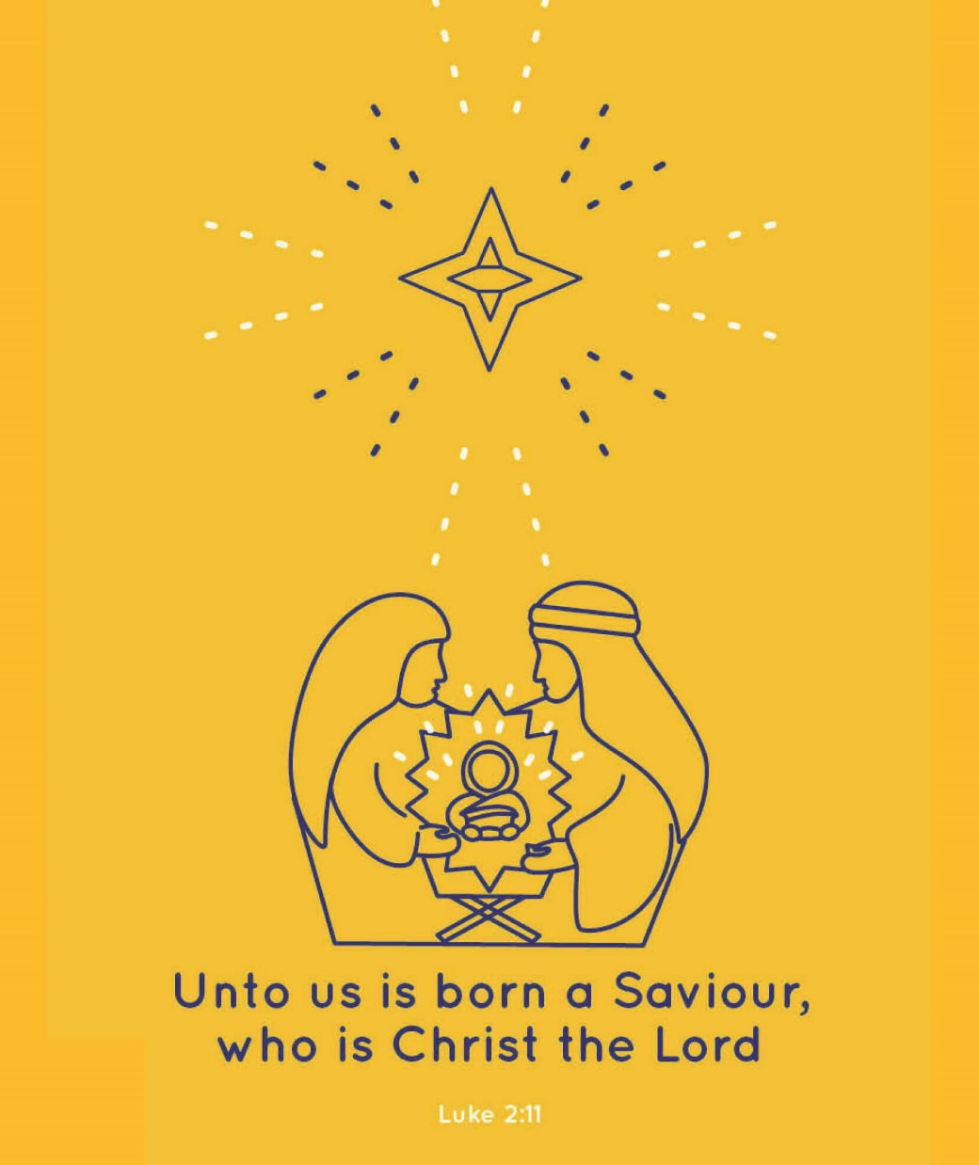

**Parish Magazine**

**What’s on in the village?**

**All of the following activities take place in the Community Centre. For further details please telephone 01946 834297**

**Baby & Toddler Group:** Every Wednesday (Term Time) 10am

**Lunch Club:** 2nd Friday of the month at 12 noon

**Family and Local History:** Every third Tuesday from 7 - 9 pm

**Art Class**: Most Tuesdays from 6.15 – 8.15 pm

**Craft Club**: Every Tuesday from 1 - 3 pm

**Evergreens**: Thursdays from 1 – 3 pm

**Reading Group:** Every second Monday from 2 pm (in the Library)

**Knit and Knatter:** Every Friday from 1 -3 pm

**“Old Folks” Bingo**: Every Monday at 8 pm

**Fit 4 Life**: Every Tuesday from 11 – 12.15 am

**Parish Council** meets every second Monday at 7 pm in the Club for Young People

**Mothers Union**: every first Wednesday in the month at 7 pm in the Community Centre

**Distington Club for Young People**: if you require further information please contact Christine on 832882

-o-o-o-o-o-o-o-o-o-o-o-o-o-o-o-o-o-o-o-o-o-o-o-o-o-o-o-o-o-o-o-

**Confirmation**

Anyone aged 11 to 100 who is interested in being confirmed, please speak to Julia.

|  |  |
| --- | --- |
|  | **John Sandelands Funeral Directors Ltd**  **Tel: 01900 602753**  **Rest Chapels at;**  Main Road, Seaton  South William St, Workington  Bridge Street, Cockermouth |

**Wall & Tree Cockermouth**

* **Hedge & Tree maintenance & removals**
* **Grass Cutting, garden tidying & clearances**
* **Small landscaping projects**
* **Fence installation, painting & repair**
* **Firewood & chainsaw work**
* **General garden D.I.Y.**

**We can work within your budget**

**Contact Dale for a no obligation quotation**

**Tel. 01900 828947 mob 07907 225 316**

**E-mail moose.moore@live.co.uk**

**THE CHURCH OF THE HOLY SPIRIT, DISTINGTON**

**Rector: Revd. Julia Powley, The Rectory, Rectory Close, Harrington, Workington, CA14 5PN Tel: 01946 830215**

**Churchwardens Marlene Pettit**

**Lay Chair Doreen Belford**

**Secretary Barbara Lamb**

**Treasurer Doreen Belford**

**Electoral Roll**

**Officer Barbara Lamb**

**PCC Members as above plus**

**Helen Finn, Julia Hoggarth, Nicola Stephenson, Pat Nelson, Rhoda Robinson, Ray Bailey & Rosalind Brough**

**Sides Persons Ann Blakemore, Joan, Milligan, Rosalind Brough, Sandra Parry, Brenda Bailey & Pat Nelson**

|  |  |  |
| --- | --- | --- |
| **For any information needed about Baptisms, Weddings or Funerals please contact**  **Revd. Julia Powley Tel: 01946 830215** | | |
| **Triple TTT Ltd**  **The Old Job Specialists doing the Jobs you hate**  ***Window cleaning – power spraying***  ***Guttering – painting – brick laying***  **Van Hire with Driver, fully insured – mini removals**  ***Grasscutting – tree pruning – hedge cutting***  ***Commercial and household cleaning***  **COMPETITIVE QUOTES**  **01900 810008**  **07934 770328** | **Advertise Here?**  **Find out more about our great yearly rates**  **for more information, contact**  **Barbara Lamb**  **07425 792 995** |
| **Brockbank Curwen Cain and Hall**  Solicitors and Notaries  44 Duke Street  Whitehaven CA28 7NR  Tel: 01946 692195  Also at Cockermouth, Maryport, Workington and Keswick   * **Home Information Packs** * **Residential and Commercial Conveyancing** * **Wills and Probate** * **Court of Protection** * **Personal Injury** * **Matrimonial** * **Crime** * **Employment**   www.brockbanks.co.uk | **DISTINGTON**  **COMMUNITY CENTRE**  **The Centre runs training events and other community activities including public meetings. The Mabel Knowles room is a committee room available for small meetings – capacity 25. The Main hall is available for events, activities, and private parties etc. – capacity 100.**  **Full new kitchen available**  **For further details**  **tel: 01946 834297** |

**Flowers**

Do you have loved ones who you like to remember with flowers?

Did you know you can display flowers in memory of your loved ones in church?

These can be displayed on the altar or throughout the church.

**For more information please speak to**

**Nicola Stephenson on 07933551524.**

**Church Memorial Book**

If anyone would like to have their loved one’s details added to our memorial book in Church, please speak with Julia Powley.

There will be a small charge of £5 per name

Dear everyone,

In the time covered by this magazine, we will have a general election, Christmas, a new year and even the possibility of being out of the EU by January 31st! That is a lot to be happening in a period when, usually, not much happens as the Christmas preparations and festivities take over from normal life. This year will be different.

First, whatever else you plan to do in December, however many dinners and nativity services are in your diary, please vote, whoever you vote for. It is so easy to think it doesn’t matter, but every vote is important. So, we need to make time for that in the middle of everything else.

Second, please pray. There is so much happening in our nation, and we will have so much presented to us by the different parties trying to get our support. Social media feeds us so much news, real and false. So we need wisdom and discernment. In the book of James in the Bible, we are promised that if we want wisdom, all we need to do is ask. So let’s ask.

Third, please remember how much God cares for us, and how much he is involved in our lives. Christmas reminds us of that, as we celebrate the Incarnation, the point where God broke into our world in human form. As it is so easy to make Christmas sentimental, this year we need to grasp the power of Christmas, the power of Jesus becoming part of our world and our lives. He is still in our world, through the Holy Spirit and through all who trust Him, including us!

The final words of one of the modern carols we sing goes as follows:

But nations now may see His grace and know that He is near,

When His meek heart, His words, His works are incarnate in us here.

I pray that this Christmas, the community around us will see Jesus in us, and that our Christmas celebrations will be more real than ever as we grasp the power of having Him in our lives. That is what Christmas is all about.

Happy Christmas, and God’s richest blessings for 2020.

With love,

Julia

The Church of the Holy Spirit warmly invites you to our…

**Baby and Toddler Group**

Distington Community Centre

Every Wednesday in school term time

10am start

Babies and toddlers with their parents/carers are welcome

£1 per family

For more information please contact Julia Hoggarth on 07747581390

**Lunch Club**

Monthly on the 2nd Friday 12noon - 2pm

Next two are;

**13th December 2019**

**10th January 2020**

Distington Community Centre

Beautiful food served at fantastic prices

One, two or three courses with tea & coffee

**Your Church Needs You!**

* To go on the rota to read a lesson
* To go on the list to lead prayers
* To go on the cleaning rota
* To go the rota to print the magazine
* To be a sidesperson
* To be a member of the PCC

If you can help, please speak with

Julia Powley

**From the Parish Registers**

**Funerals**

May they Rest in Peace

**Blanche Lamb**

Age 90 years

Died 7th October 2019

Funeral 23rd October 2019

**Website**

We have a new website for the United Benefice which covers the activities of both St Mary’s Harrington and The Holy Spirit Distington. The website is still in development, so we are looking for comments and ideas to include. Have a look and tell either James Mossop or Andrew Callaway (me!) what you think. The web address is [www.stmarys-harrington-and-holyspirit-distington.co](http://www.stmarys-harrington-and-holyspirit-distington.co) If you want to email your thoughts my email address is [a.callaway@talktalk.net](mailto:a.callaway@talktalk.net)

Thanks Andrew

**CHURCH CLEANING ROTA**

**DECEMBER 2019**

1st Julia & Helen

8th Lynda & Edwina

15th Sandra & Trudy

22nd All hands-on deck for Christmas 29th Katrina & Carl

**JANUARY 2020**

4th Julia & Helen

11th Lynda & Edwina

18th Sandra & Trudy

25th Katrina & Carl

February 2nd Julia & Helen

If you are unable to make the week you are due to clean, please let Sandra know on 01946 830046.

**Church of the Holy Spirit**

**Future Dates for your Diary!**

**Christingle**

10th December 2019 6pm in Church

**Distington School Carol Service**

20th December 2019 9.15am in Church

**Carols by Candlelight**

22nd December 2019 4pm in Church

**Crib Service**

24th December 2019 5.30pm in Church

**Midnight Mass**

24th December 2019 11.30pm in Church

**Coffee, Cake and Craic**

Distington Methodist Chapel

Most Wednesdays

from 10.15am

All Welcome

|  |  |  |  |  |
| --- | --- | --- | --- | --- |
|  | **READINGS** | **READER** | **SIDESPERSON** | **FLOWERS** |
| **1st December** | **Isaiah 2 vs 1 - 5 Matthew 24 vs 36 - 44** | **Childrens Church** | **Sandra Parry Ann Blakemore** | **Nicola Stephenson** |
|
| **8th December** | **Isaiah 11 vs 1 - 10 Matthew 3 vs 1 - 12** | **Ray Bailey Rector** | **Sandra Parry Ann Blakemore** | **Nicola Stephenson** |
|
| **15th December** | **Isaiah 35 vs 1 - 10 Matthew 11 vs 2 - 11** | **Doreen Belford Rector** | **Rosalind Brough Barbara Lamb** | **Parishioners** |
|
| **22nd December** |  | **Various** | **Rosalind Brough Barbara Lamb** | **Parishioners** |
|
| **24th December** | **Isaiah 52 vs 7 - 10 John 1 vs 1 - 14** |  |  |  |
|
| **25th December** | **Isaiah 62 vs 6 - end Luke 2 vs 1 - 20** |  |  |  |
|
| **29th December** | **Isaiah 63 vs 7 - 9 Matthew 2 vs 13 - end** | **Sandra Rector** | **Barbara Lamb Brenda Bailey** | **Parishioners** |
|
|  |  |  |  |  |
|  | **READINGS** | **READER** | **SIDESPERSON** | **FLOWERS** |
| **5th January** | **Isaiah 60 vs 1 - 6 Matthew 2 vs 1 - 12** | **Childrens Church** | **Barbara Lamb Brenda Bailey** | **Parishioners** |
|
| **12th January** | **Isaiah 42 vs 1 - 9 Matthew 3 vs 13 - end** | **Ray Bailey Rector** | **Sandra Parry Ann Blakemore** | **Mrs Kirkbride** |
|
| **19th January** | **1 Corinthians 1 vs 1 - 9 John 1 vs 29 - 42** | **Julia Hoggarth Rector** | **Sandra Parry Ann Blakemore** | **Marlene Pettit** |
|
| **26th January** | **1 Corinthians 1 vs 10 - 18 Matthew 4 vs 12 - 23** | **Doreen Belford Rector** | **Rosalind Brough Pat Nelson** | **Barbara Lamb** |
|

**Thank You**

Myra Allen has recently moved to a care home in the North East to be closer to her family.

We would like to take the opportunity to thank Myra for all the work she did over the years for our village church.

Our prayers are with you and hope that you enjoy living closer to your family.

|  |  |
| --- | --- |
| **DECEMBER** | |
| **Date** | **Event** |
| Sun 01/12/2019 | 9.15am - Family Worship |
| Wed 04/12/2019 | 9.30am - Holy Communion 10am - Toddler Group in Community Centre |
| Sun 08/12/2019 | 9.15am - Holy Communion |
| Tue 10/12/2019 | 6pm - Christingle Service |
| Wed 11/12/2019 | 9.30am - Holy Communion 10am - Toddler Group in Community Centre 7pm - Carol Concert with Cockermouth Ukelele Band in the Old Chapel |
| Sun 15/12/2019 | 3pm - Church in the Afternoon |
| Wed 18/12/2019 | NO COMMUNION SERVICE 10am - Toddler Group in Community Centre |
| Fri 20/12/2019 | 9.15am - Distington School Carol Service |
| Sun 22/12/2019 | 4pm - Carols by Candlelight |
| Tue 24/12/2019 | 5.30pm - Crib Service 11.30pm - Midnight Communion |
| Wed 25/12/2019 | 9.15am - Christmas Day Communion |
| Sun 29/12/2019 | 9.15am - Holy Communion |

If anyone would like communion at home or a visit from Julia.

Please contact Julia on 01946 830214

|  |  |
| --- | --- |
| **JANUARY** | |
| **Date** | **Event** |
| Sun 05/01/2020 | 9.15am - Family Worship |
| Wed 08/01/2020 | 9.30am - Holy Communion 10am - Toddler Group in Community Centre |
| Sun 12/01/2020 | 9.15am - Holy Communion |
| Wed 15/01/2020 | 9.30am - Holy Communion 10am - Toddler Group in Community Centre |
| Sun 19/01/2020 | 3pm - Church in the Afternoon |
| Wed 22/01/2020 | 9.30am - Holy Communion 10am - Toddler Group in Community Centre |
| Sun 26/01/2020 | 9.15am - Holy Communion |
| Wed 29/01/2020 | 9.30am - Holy Communion 10am - Toddler Group in Community Centre |

**100 Club Winners**

September – No 5 – Christopher Lamb

October – No 2 – Leo Belford

November – No 10 – Margaret Steele

December – No 15 – Eileen Weighman

January – No 25 – Barbara Lamb

